DeskLink App
User Guide
eMAM Version 5.0

Notice
The content in this document represents the current view of Empress Media Asset Management, LLC as of the date of publication. As Empress responds continually to the changing market conditions, this document should not be interpreted as a commitment on the part of Empress. Empress cannot guarantee the accuracy of any information presented after the date of publication.
Empress is a US registered trademark of Empress Media Inc. and is used by permission. eMAM logos are US registered trademarks of Empress Media Asset Management, LLC.
Information in this document is subject to change without notice.
Revision History
eMAM Version | Date | Author | Reviewed By | Description
3.8 | April 2017 |  |  | Released eMAM 3.8 version
 | Dec 2017 |  |  | Added Upload and Dashboard tab details
5.0 | Jan 2018 |  |  | Added download option through My Account page.
5.0.0.14 | Sept 2018 |  |  | Updated "Ingest without embedded metadata" option.

Contents

Introduction 4

Overview 4

What is DeskLink 4

Installation 4

1. Download DeskLink from Projects/Categories/eBIN widget 5

2. Download DeskLink from My Account page 8

Launch DeskLink 10

Overview of DeskLink 12

Major Functions and Features 15

1. Download Manager 15

2. Upload Manager 21

3. Desktop Asset Browser 25

3.1 Archive/Restore 25

3.2 Dashboard 27

3.3 Projects tab 29

3.4 Categories tab 30

3.5 Assets tab 31

3.6 Search 32

3.7 Folder/List View 33

3.8 Refresh 34

3.9 Logout 34

3.10 Asset options window 34

Get Help 37

Table of Figures 37

Introduction
eMAM is an all-in-one, web-based Media Asset Management (MAM) software system designed to organize, share, and collaborate digitized information such as audios, videos, images, and documents. We have taken a ground-breaking approach to create a flexible, feature-rich, and modular digital asset management platform to meet asset management requirements of individuals, as well as major enterprises. DeskLink app has been introduced for improved and easy media download and management. It can act as a download manager, an upload manager and a desktop asset browser. Using this mini eMAM app, you can download assets from a project or category, view various asset options, apply search filters, and customize your browse with pages and view choice (thumbnail or list).

Overview
This document will help you get started with DeskLink and will provide you details on how to install, launch and use DeskLink for download, upload and as a desktop asset browser.

What is DeskLink
DeskLink is a cross platform desktop application with download, upload and browse options. This new DeskLink app is built on Node.js technology and loads inside the nw.js runtime environment (https://nwjs.io/) which gets automatically downloaded and installed in your computer.
DeskLink paves a new way to interact with eMAM which helps users to browse projects/categories and assets without any browser support and can also act as a download manager and upload manager. Using this mini eMAM app, you can bulk download of assets from Project/Category/eBIN, upload assets to eMAM and also view various asset options, apply search filters, apply paging, view assets in a thumbnail or list view etc. DeskLink can be used for dynamic downloads with dashboard option where you can see the progress and status of all downloads made by you.

Installation
You can easily download and install DeskLink application using any of the below two options from the eMAM Director interface:
- Download DeskLink using Download option under Projects/Categories/eBIN widget
- Download DeskLink from My Account page.

Download DeskLink from Projects/Categories/eBIN widget

You can download and install DeskLink using Download option under Project/Category/eBIN widget in the eMAM Director interface. (One-time process). For all the subsequent download of assets from the Projects, Categories and eBIN, DeskLink download page automatically opens or you can also directly launch DeskLink app from your desktop for download purpose. Follow below instructions to install DeskLink app on your machine:
- In the eMAM Director Interface, click on Download option from any of the below widgets:
  - Projects: Click on a project under Projects widget and select Download from project menu options as shown below:

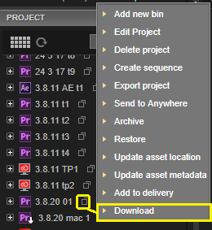

Figure 1- Select Download from Project menu options.
  - Categories: Click on a category under Category widget and select Download from category menu options as shown below:

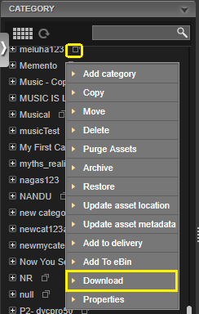

Figure 2- Select Download from Category menu options
  - eBIN: Select Download option from eBIN widget pull down menu.
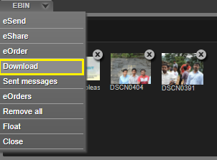

Figure 3- Select Download from eBIN widget menu
- DeskLink app download window opens up (it will close automatically after 20 secs). Based on your machine type, download DeskLink by clicking on the Mac or Windows button.
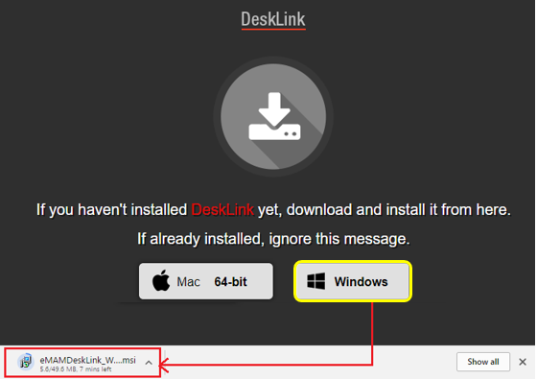

Figure 4- Download DeskLink: Windows 64 bit

- Run the downloaded file and open the DeskLink Setup wizard. Click Next and follow the installer instructions to install DeskLink app on your machine. After installation is complete, click Close to exit. This is a onetime process.

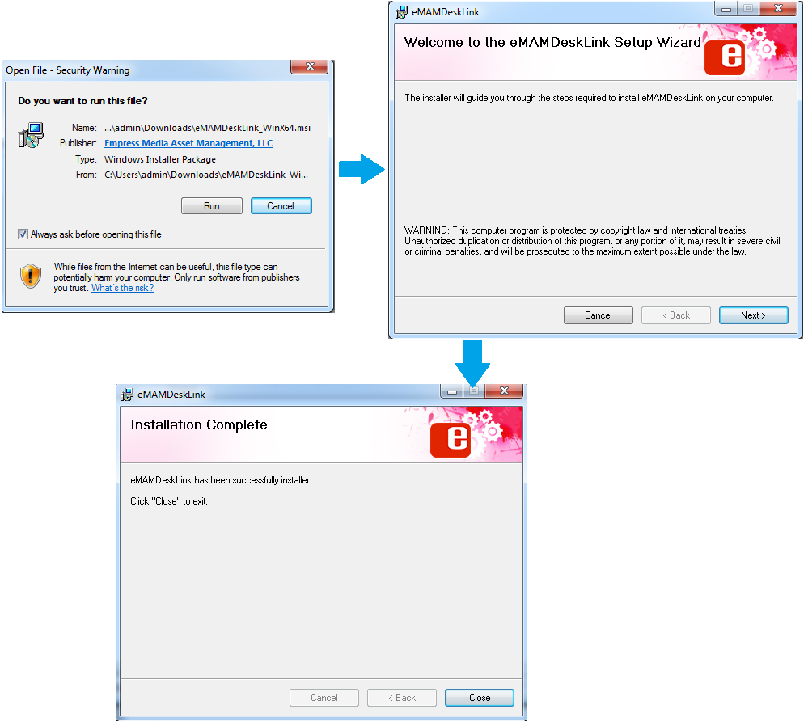

Figure 5- Run the downloaded file to install DeskLink
- After successful download, you can either reinitiate the download process from the eMAM Director interface to proceed with download of the assets under Project/Category/eBIN widget or launch DeskLink app from your desktop to proceed with download.

Download DeskLink from My Account page

You can also download and install DeskLink from eMAM Director> My Account page following the steps below:

- Login to eMAM Director interface. Click on Settings green radial button and then click on My Account.

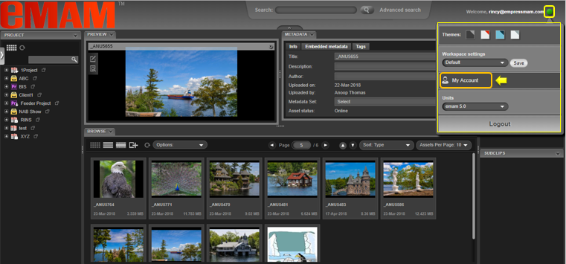

- A new window opens up for My Account. On the left-hand side panel, click on Apps.
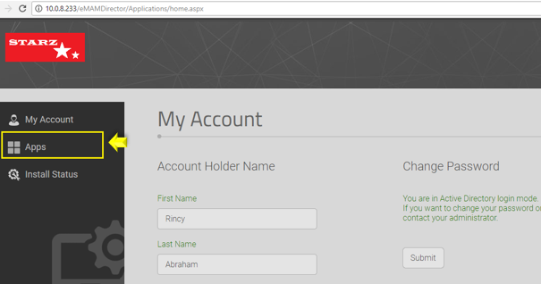

- Now click on DeskLink icon box as shown below.
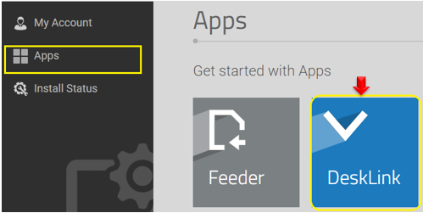
- Based on the type of your machine, click on the MAC or Windows button to download the installer package.
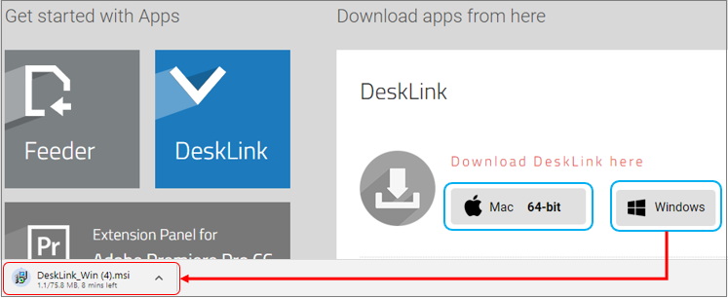
- Run the downloaded file and open the DeskLink Setup wizard. Click Next and follow the installer instructions to install DeskLink app on your machine. After installation is complete, click Close to exit. This is a onetime process.

Launch DeskLink
- After successful installation, click on the DeskLink icon from your desktop to launch it.

Figure 6- Launch DeskLink
- Enter Gateway and Director server URL and click on Start button.

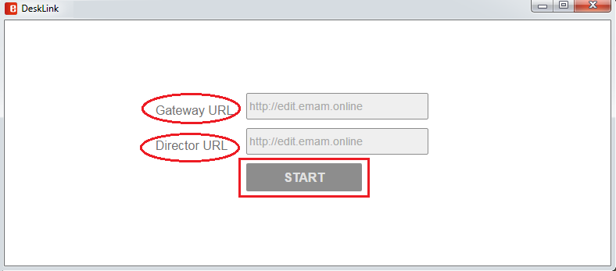

Figure 7- DeskLink: Key in Gateway and Director URL
- Login using eMAM credentials. To change eMAM server details, click on Change eMAM Server button and you will be taken back to screen shown above to enter the URL details..
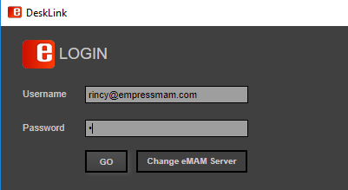

Figure 8- DeskLink: Login page
- Select appropriate unit if your account is associated with multiple units.
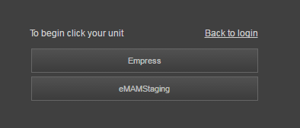

Figure 9-Select Unit
- After successful login, DeskLink home page is displayed.
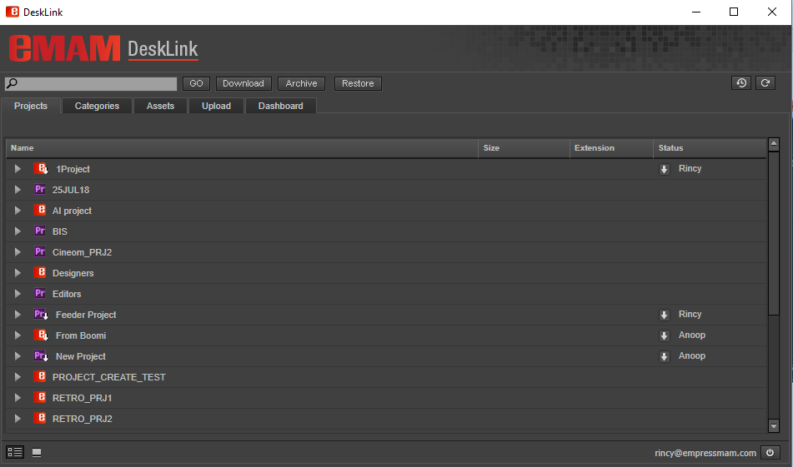

Figure 10-DeskLink home page

Overview of DeskLink
DeskLink home page looks quite similar to eMAM Premiere panel home page except for few additional functions.
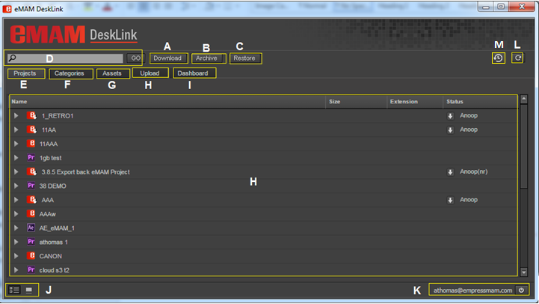

Figure 11- DeskLink home page overview
DeskLink home page with various buttons and functions which are explained in detail below:
- Download: One of the major functions of DeskLink app is download, which is performed using this Download button. Download action can be performed for the assets under Projects/Categories and Assets Tab. Refer section Download Manager.
- Archive: Archives the assets to the pre-set archive profile. Refer section Archive/Restore.
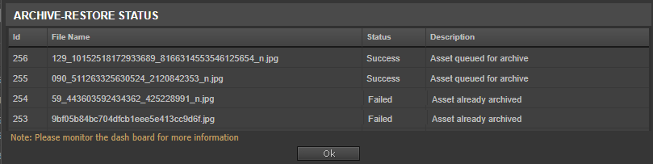

Figure 12- Archive-Restore status window for Archive

- Restore: Restores the archived assets. Refer section Archive/Restore.
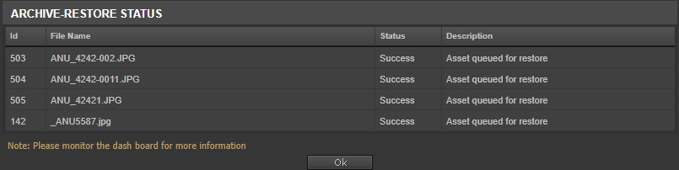

Figure 13- Archive-Restore status window for Restore
- Search: Search for assets under Project/Categories/Assets tab. Refer section Search.

Figure 14-Search bar
- Projects: Projects tab displays list of projects in the eMAM system. Refer section Projects tab.
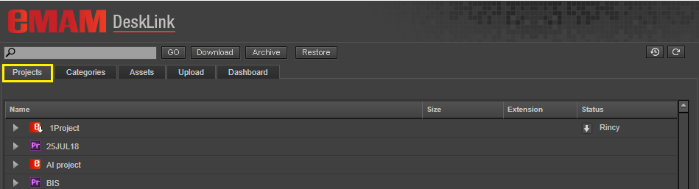

Figure 15- Projects Tab
- Categories: Categories tab displays list of categories created in the eMAM system. Refer section Categories tab.
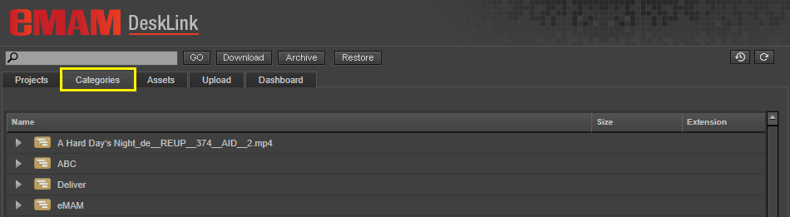

Figure 16- Categories Tab
- Assets: Assets tab displays list of all assets in the eMAM system. Refer section Assets tab.
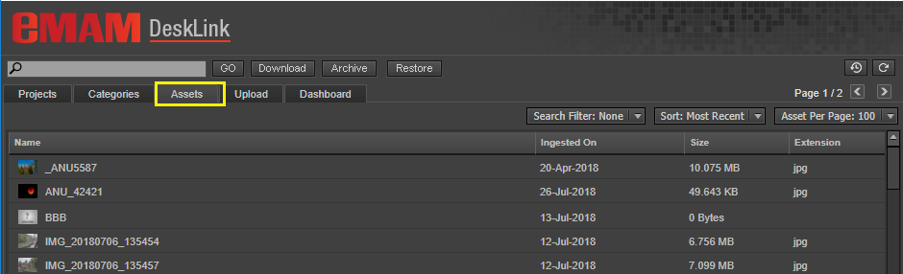

Figure 17- Assets Tab
- Upload: Upload button helps to upload assets to the eMAM system. Refer section Upload Manager.
- Dashboard: Dashboard tab can be used to monitor list of assets and their statuses on various actions performed like Ingest, delivery, archive, cloud and purge. Refer section Dashboard.
- Thumbnail & List view: Option to view Projects/Categories and Assets tab in thumbnail or list view. Refer section Folder/List View.
- User and Logout: Name of the logged in user and option to logout from DeskLink. Refer section Logout.
- Refresh: Refresh button to refresh and see the latest changes in the eMAM system. Refer section Refresh.
- Download History: Click on this icon to view the history of all downloads made by you in a new window. Refer section History tab.
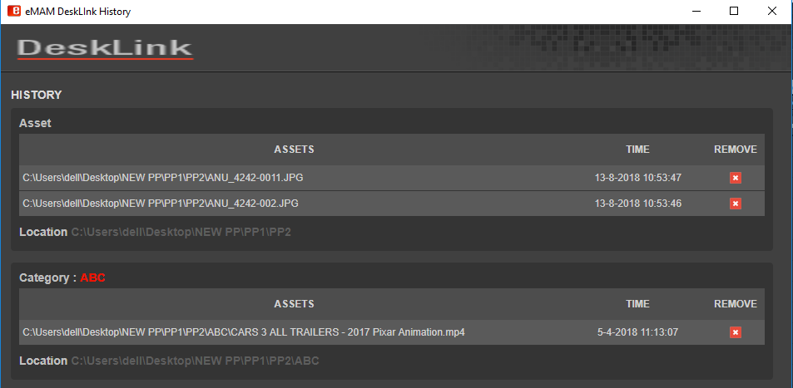

Figure 18- DeskLink download history window

Major Functions and Features
DeskLink is a feature rich app with various functions and capabilities. Three main functions and other features relating to it are listed below. It can act as:
- Download Manager
- Upload Manager
- Desktop Asset Browser

Download Manager
DeskLink can act as Download manager which will help you to download the assets under Projects/Categories/eBIN to a specified location from eMAM Director interface. If multiple assets need to be downloaded, add all of them to eBIN and download it from there. You can not only monitor the download progress but also can view the list of all downloads made by you under the History tab of DeskLink.
Follow the steps below for download of assets:
- In the eMAM Director interface, select the Project/Category/eBIN for download and click on Download option from its menu list.
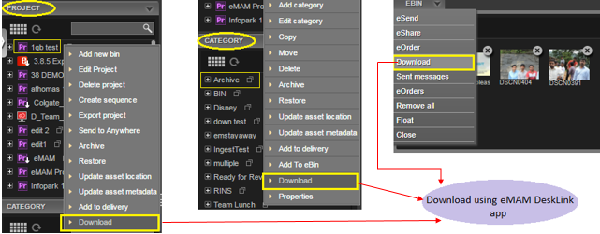

Figure 19- Download from Project, Category and eBIN widget
- DeskLink app download page opens up. If DeskLink app is not installed yet on your desktop, install it from this page. If already installed, after a while DeskLink page opens up automatically and download page automatically closes in 20 seconds. (skip step 3 & 4 and continue from step 5.)
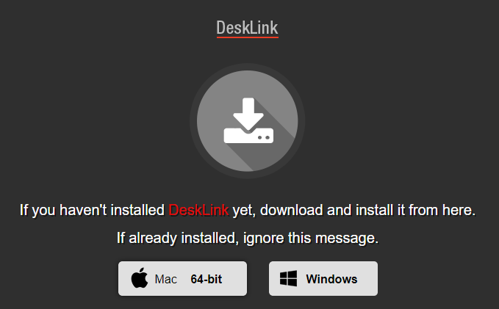

Figure 20- DeskLink app download page (automatically closes after 20 secs)
- OR, directly launch DeskLink app from your desktop (if already installed).
- Select the assets for download under Projects/Categories/Assets tab and click on Download button.
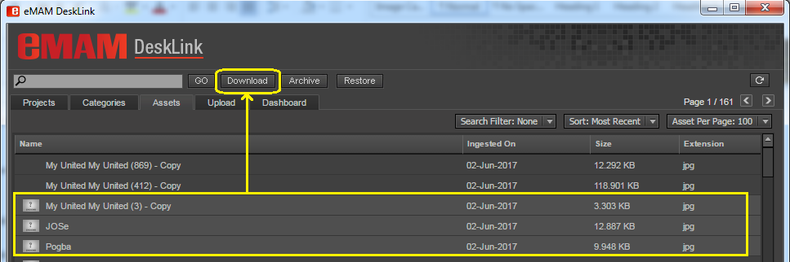

Figure 21- Use Download button for download of assets under Projects, Categories and Assets tab.

- DeskLink download window opens up to choose the download location.
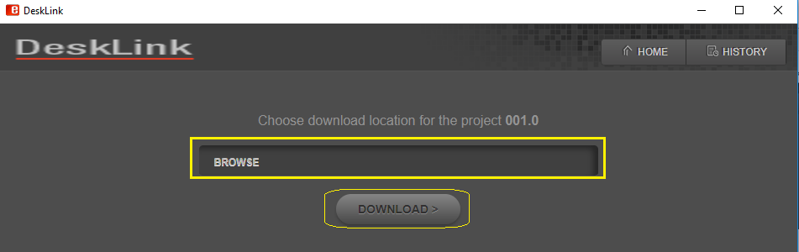

Figure 22- DeskLink download page to choose download location
- Under Home tab, click on Browse button and choose the destination location for download of assets. Then click on Download button.
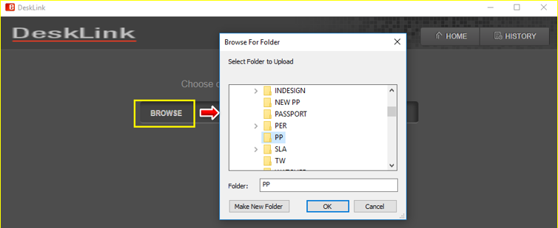

Figure 23- Browse and choose destination for download
- Download process gets initiated and all the assets under the chosen Project/Category/eBIN starts to get downloaded one by one to the specified location. User can see the details of assets getting downloaded like asset name, asset size, and the download progress bar in percentage.
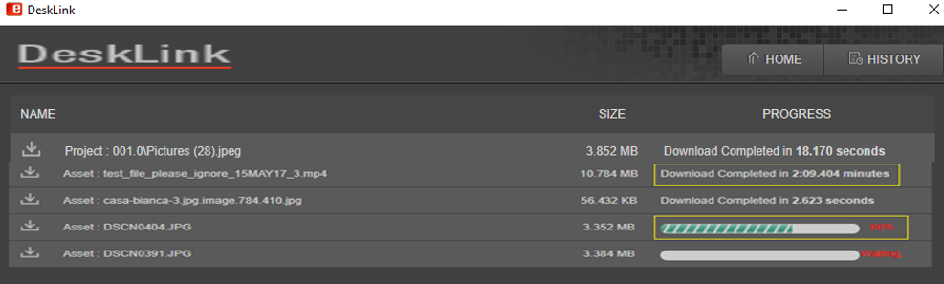

Figure 24- DeskLink: Download in Progress
- Once the download is complete, a download complete message is displayed for each asset along with the time taken to download the asset.
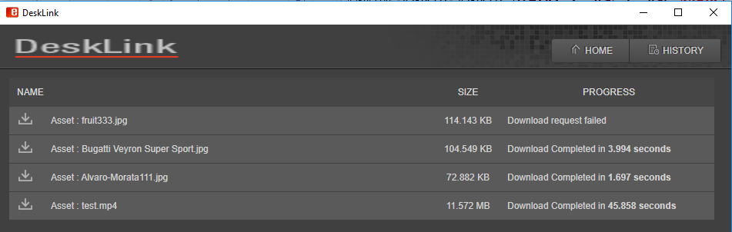

Figure 25: eMAM Download Manager- Download complete message

If download process fails for some reason, it throws up error messages as shown below:

Figure 26- error message when asset download fails
- History tab: Click on the History tab to display the details of all the assets downloaded by you from the Project, Category and eBIN widget. Details include asset download location, date and time of download and option to remove from the list using X icon. The download history of all the downloaded assets (including multiple instances of download) will also be available under the History widget of the eMAM Director Interface.
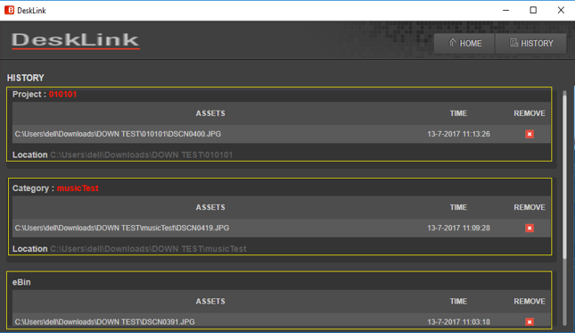

Figure 27- DeskLink: History tab
Click on Remove icon to remove any asset details from the download history. Before deletion, you will be prompted with a confirmation message box. Click OK to continue.
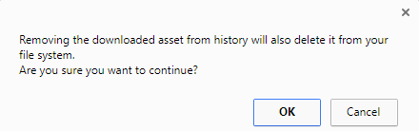

Figure 28- Confirmation box before deletion

If all the assets are deleted from a particular location, below message appears.
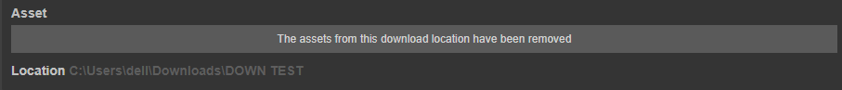

Figure 29- Message displayed when all the assets are deleted from a location.

Click on icon on top right-hand side of the page to go back to DeskLink home page.
Note:
- DeskLink can handle multiple instances of download from project/category/eBIN in different windows.
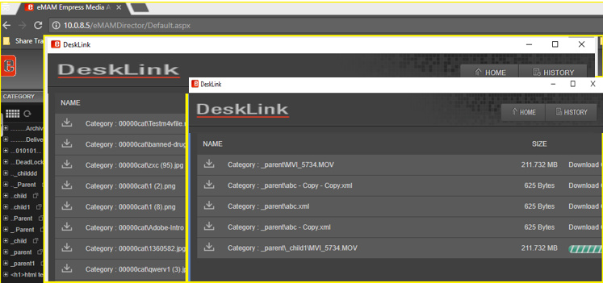

Figure 30- Multiple download windows
- Un-installation of DeskLink app may lose all the details from the DeskLink history tab locally but all details will be available in the History widget of eMAM Director Interface.

Upload Manager
You can use DeskLink to upload assets to the eMAM system. Click on Upload tab on the top menu and below page displays. Like eMAM Feeder, you have option to add files/add folders and upload.
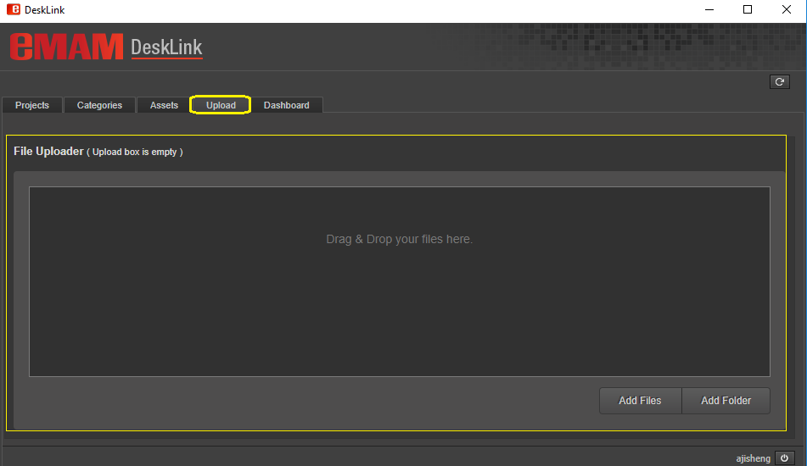

Figure 31- Upload tab to upload assets to eMAM
- Click on Add files button/add folder button and select the files/folders for upload. You can also directly drag and drop the files to the main center area.
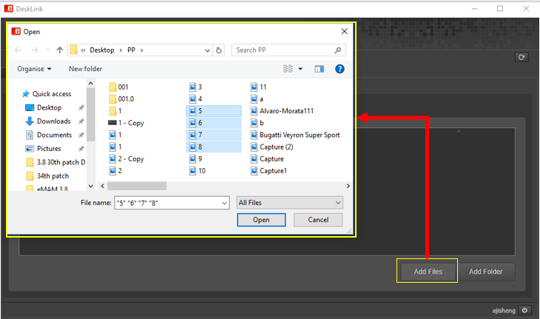

Figure 32- Upload- Adding files from local machine
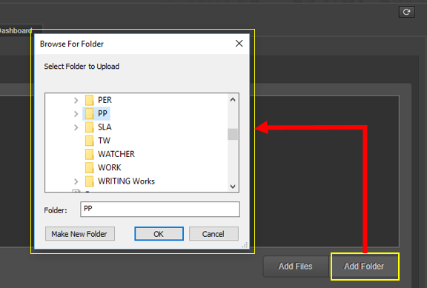

Figure 33- Upload- Adding folders from local machine
- Asset metadata window pops up. Fill in the assets details like title, description and author, ingest profile, MD5 checksum, projects, categories, tags, custom metadata and click the Save button.
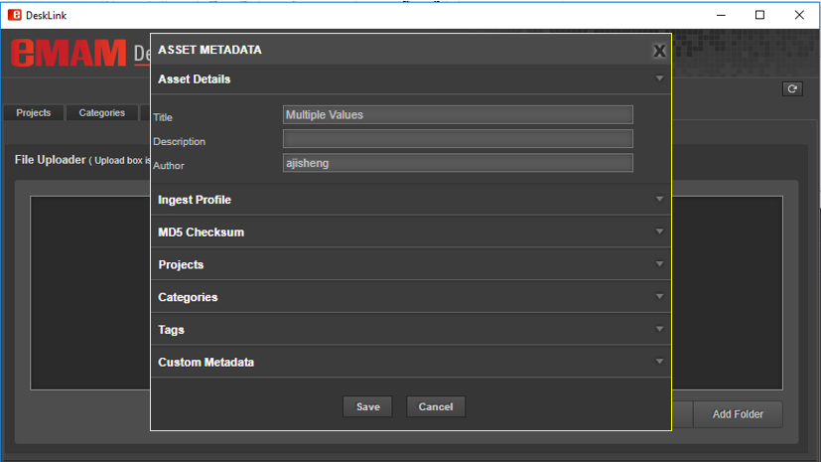

Figure 34-Asset metadata window
- All the selected files get added to the main display area. Before uploading to the eMAM system, you can make changes to the added file list either using edit icon or delete icon. User Clear button to totally remove the list of added files.
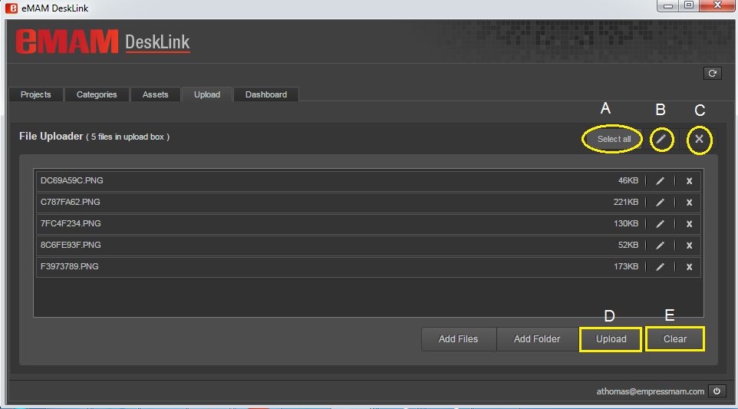

Figure 35- Files added for Upload
You can use below options (refer above screenshot):
- Select All: Use this option to select all the added files.
- Edit icon: If you wish to edit metadata details of any assets, click on edit icon and asset metadata window opens up. Makes desired changes and then click Save button.
- Remove icon: If you wish to remove any particular asset from the added list, click on the asset(s) and click on remove icon.
- Upload button: All the added files can be uploaded to eMAM by clicking on Upload button.
- Clear button: If you wish to remove all the assets selected for upload, click on Clear button. Below dialog box appears. Click Yes to remove all the assets from upload queue.

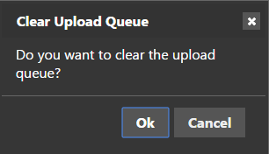

Figure 36- Message box
- Once all the files are added and ready for upload, click on Upload button. Files start to upload one by one. Upload progress of each file can be monitored using upload % displayed.
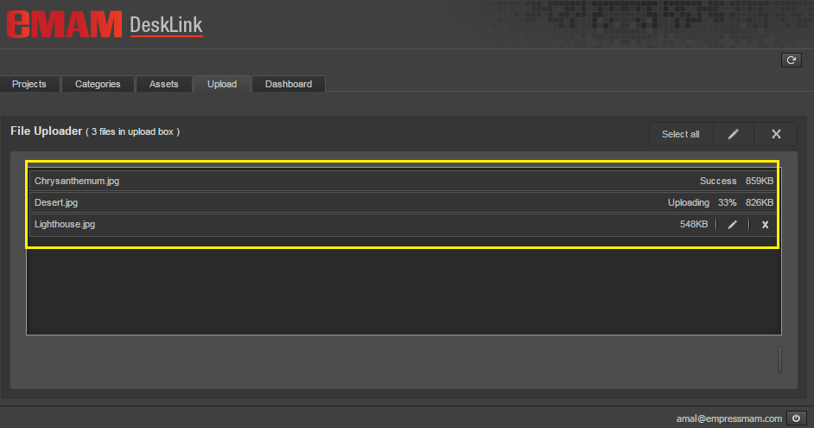

Figure 37- DeskLink: Upload in progress
- Once all the files get uploaded successfully, upload box gets empty and below pop up message is displayed.
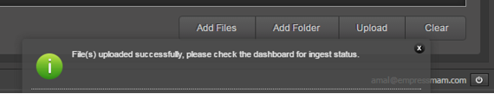

Figure 38- DeskLink: Upload successful message
- Check Dashboard tab to monitor the ingest status of the uploaded assets.
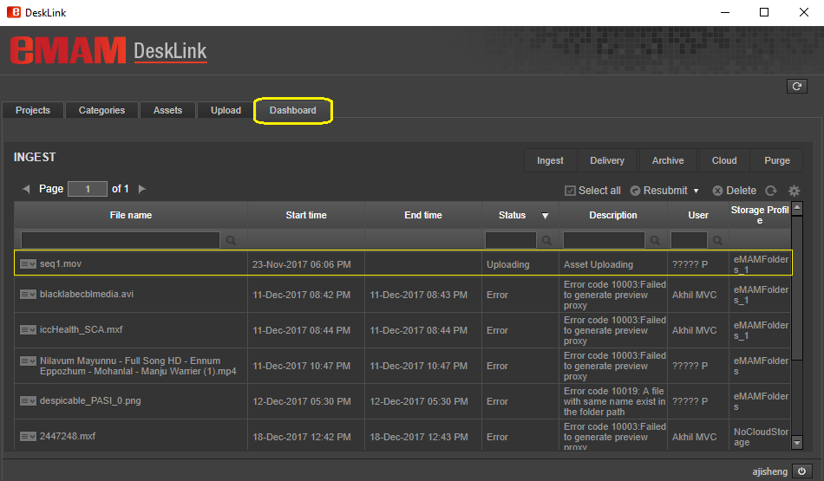

Figure 39-DeskLink: Monitor Dashboard for ingest progress.
- Desktop Asset Browser
DeskLink can also be used as a browsing desktop app to browse projects, categories, assets in the eMAM system. Launch DeskLink app that is already installed on your machine. DeskLink window opens up displaying list of assets under Projects, Categories and Assets tab (as shown below).
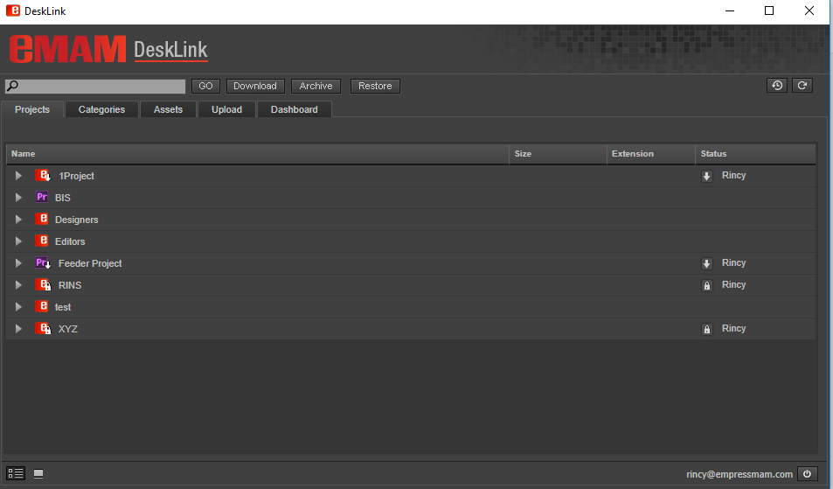

Figure 40- DeskLink: Home page
In this page, you can perform various functions like search, download, upload, archive and restore, dashboard etc. Use search box to search for assets under projects/categories/assets tab. You can choose to display the items in list or folder view using list view or folder view icon at the bottom of the window. Double click on any asset to view asset details under assets options window.
Mentioned below are few functions and features that can be performed from DeskLink home page:

Archive/Restore
Using Archive option, assets under projects, categories and assets tab can be archived to pre-defined archive locations. Click on a project/bin, a category or assets and click on the Archive or Restore button (based on their status).
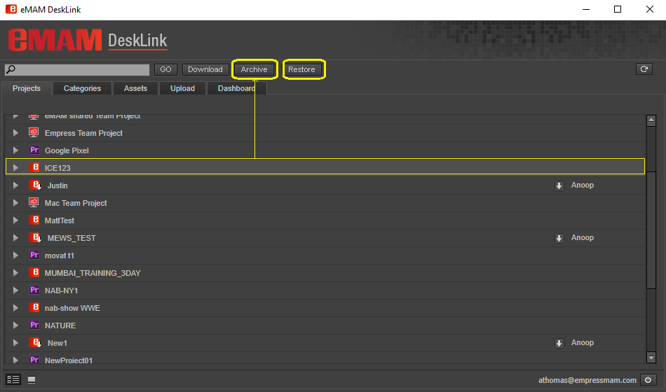

Figure 41- Archive/Restore selected project
Click on Archive button, will archive the selected project/category/asset based on default archive profile settings.
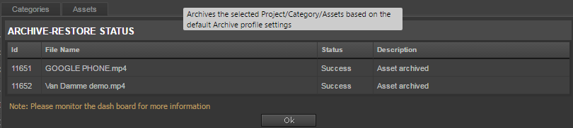

Figure 42- Archive status
Click on Restore button, will restore the select archived assets under project/category/asset tab based on the default archive settings. The Archive-Restore status window pops up, displaying the file name and its status.

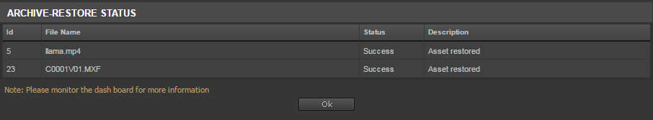

Figure 43- Restore status
In case if archive or restore of assets fail for some reason, below error message gets displayed:
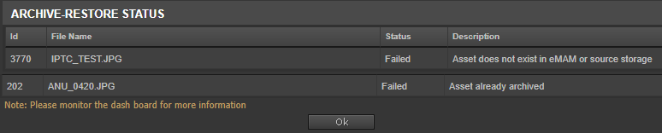

Figure 44- Archive Restore status

Dashboard
Dashboard tab displays status of various actions performed on the assets such as ingest, delivery, archive, cloud and purge operations. DeskLink dashboard is a replica of eMAM Director Dashboard. Similar to eMAM Director Dashboard, you can easily monitor the various queue (Ingest, Delivery, Archive, Cloud, Purge) for job statuses with an option to select the jobs in the queue and resubmit or delete them.
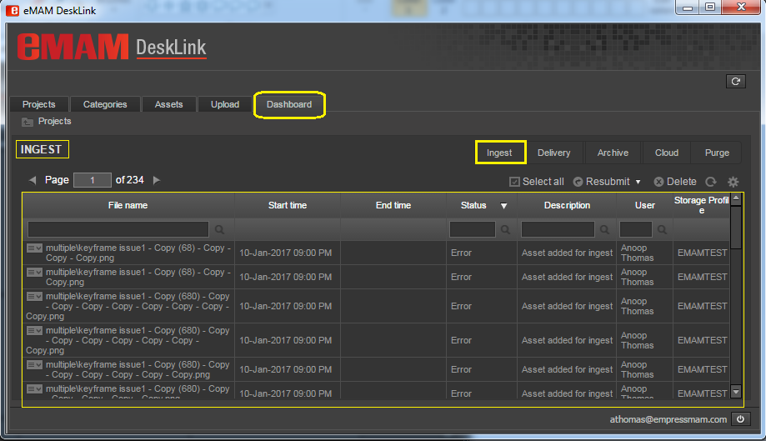

Figure 45- DeskLink Dashboard tab
Ingest, Delivery, Archive & Cloud tabs will have below options:
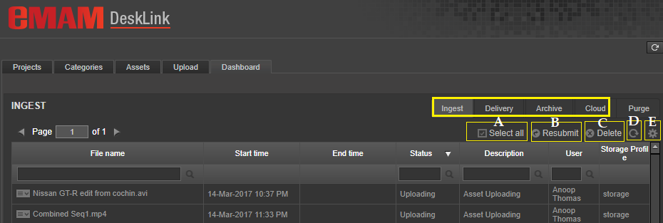
- Select All : Use this option to select all the jobs listed under the tab at one click for bulk operations. Use Remove Selection to deselect all. Use Clear Selection to de select a individual selections.
- Resubmit : Use this Resubmit option to resubmit selected jobs back for processing. Select the failed assets and click on Resubmit button; choose any of the following options along with priority (1-5) before resubmitting it back to queue:

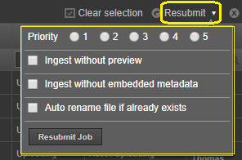
  - Ingest without preview: Failed assets will be re-ingested without preview copy.
  - Ingest without embedded metadata: Assets will be ingested without embedded metadata. (This option can be used for files which fail ingest at ImageMagick level as metadata cannot be extracted. Here the Ingest manager will skip the ImageMagick embedded metadata extraction and will fetch only the basic metadata properties such as filename, author etc. as part of embedded metadata.)
  - Auto rename file if already exists: Duplicate files which fail during ingest will be auto renamed and resubmitted for ingest.
- Delete : Use Delete option to delete selected jobs from the queue.
- Refresh : Use Refresh icon to refresh the page and update the queue with latest changes.
- Settings : Use Settings icon to set the set below:
  - Refresh Interval: (10 sec, 30 sec, 1 min, 5 min, 10 min)
  - Asset Per Page: (10,25,50,100, All)

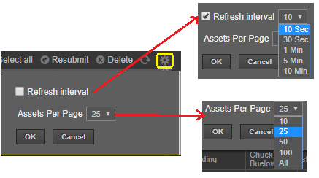

Figure 46- Settings icon
As shown below Purge tab will not have above options (Select All, Resubmit, Delete) except Refresh and Settings icon.
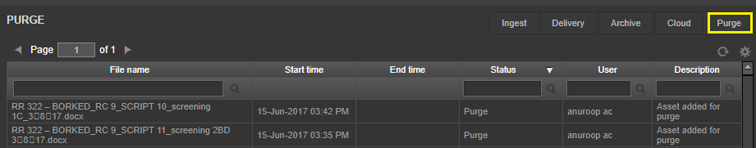

Figure 47- Purge tab

Projects tab
This tab displays list of all the projects in the eMAM system. This includes projects created in eMAM interfaces, Premiere projects and Team projects. Click on icon to expand and view the list of assets, bins, sequences etc. under each project.

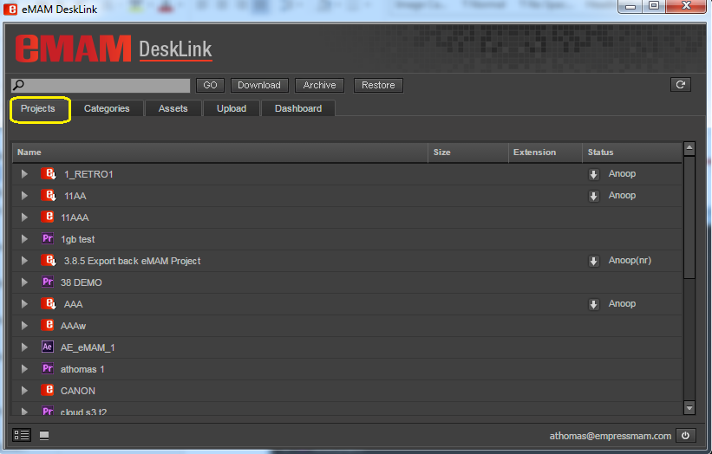

Figure 48- DeskLink Projects tab

Categories tab
This tab displays all the categories created in the eMAM system. Click on icon to expand and view the list of sub categories, assets under that category.

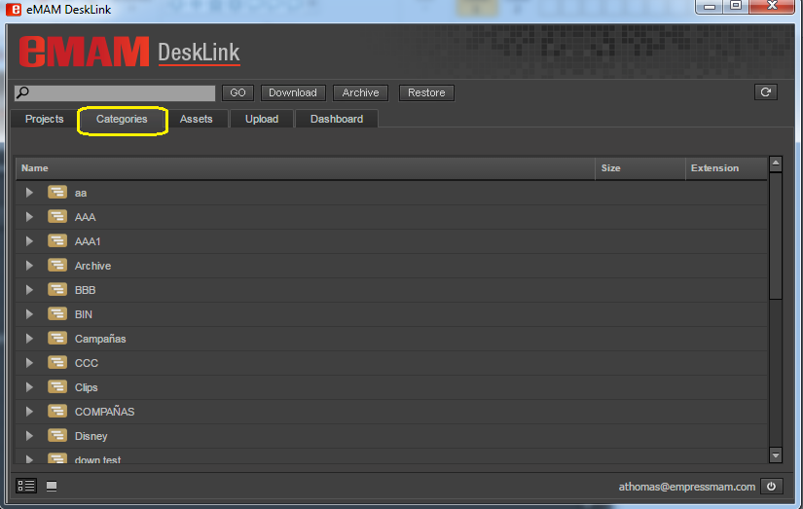

Figure 49- DeskLink Categories tab

Assets tab
This tab displays all assets in the eMAM system.

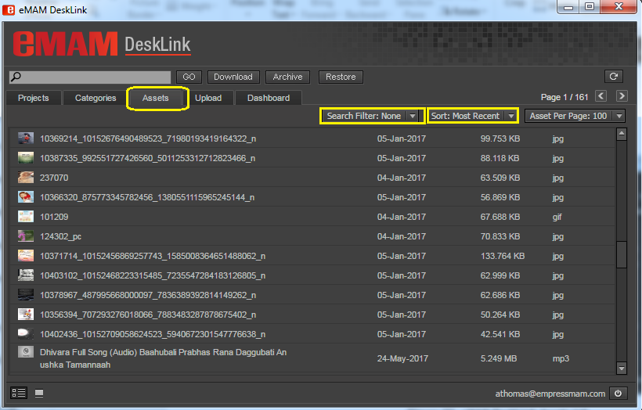

Figure 50- DeskLink Assets tab
Different options available under Assets tabs are:
• Search filter: Search filter displays list of all Saved filters from eMAM Director interface which can be used to search for assets in InDesign panel too.
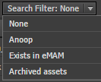
• Sort options: You can sort assets displayed based on various criteria’s like most recent, size, name, rating, description, category, ingested on and ingested by.
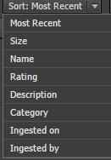
• Asset per page: You can use this option to change the no. of assets (10, 50, 100, 150, 200, 250) displayed per page.
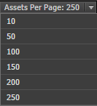
• Page navigation : This displays the current page no. and the next/previous buttons to navigate from one page to another.

Search
DeskLink can be used to search for projects/categories/assets using search box on the top panel. Depending on the tab chosen, you can use this function to search for projects, categories, or assets with the given name.
Type in the Search box on the top panel. As you start typing, a list of matching suggestions gets auto displayed. This will make it easier for you to choose from. Click GO to execute the search function and the results gets displayed under respective tab.
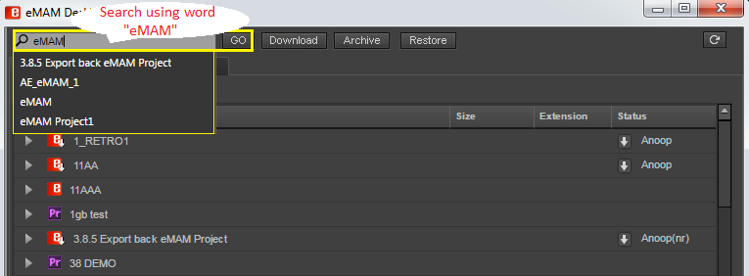

Figure 51- Search with auto populate option
Click on icon next to the search phrase to clear the displayed search results and go back to home page.
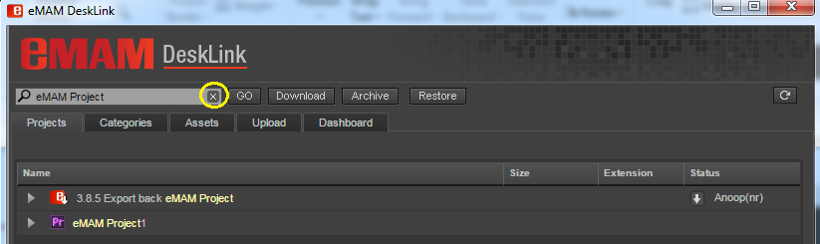

Figure 52- Search option to clear search results

Folder/List View
By default, projects/categories and assets tab are displayed in list view. You can also view Projects/Categories/Assets in folder/thumbnail view by clicking on symbol. To switch back to list view, click on symbol.
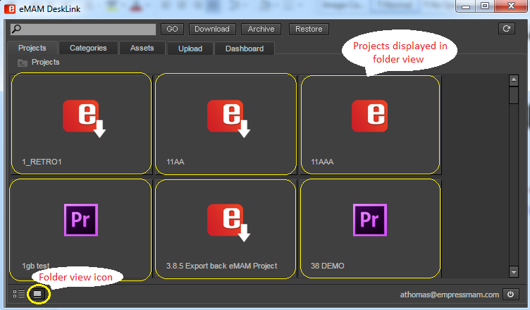

Figure 53- Folder view of projects

Refresh
Using this icon displayed at the top right of the page, you can refresh the page to see the latest changes made in the eMAM Director interface.

Logout
Username and logout symbol is displayed at the bottom right of the page. Click on this icon to logout from DeskLink.

Asset options window
When you double click on any asset under Projects/Categories/Assets tab, asset options window pops up. Various asset options tabs like Preview, Metadata, History, Comments, Approval, File versions are available depending upon the type of asset chosen.

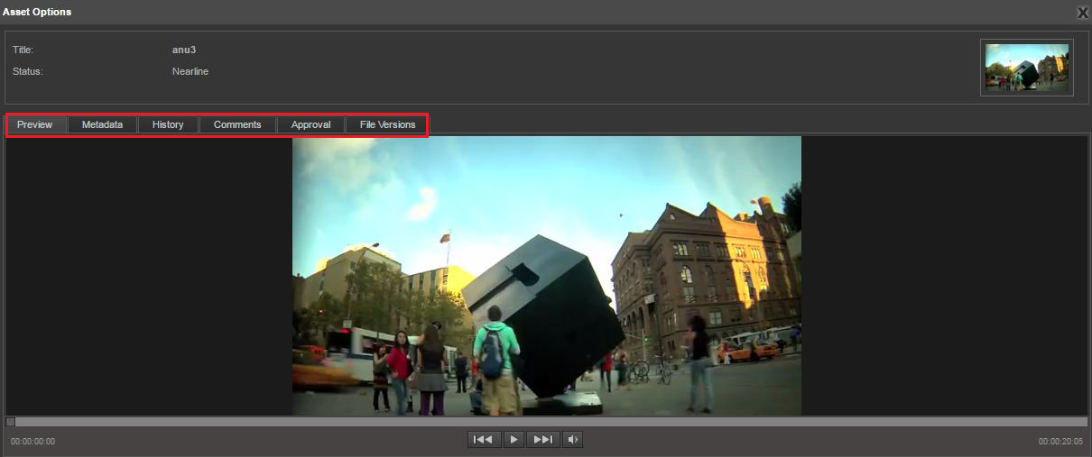

Figure 54- DeskLink Asset options window

    - Preview tab: Under preview tab, you can preview any asset individually and view its properties like name, status etc.

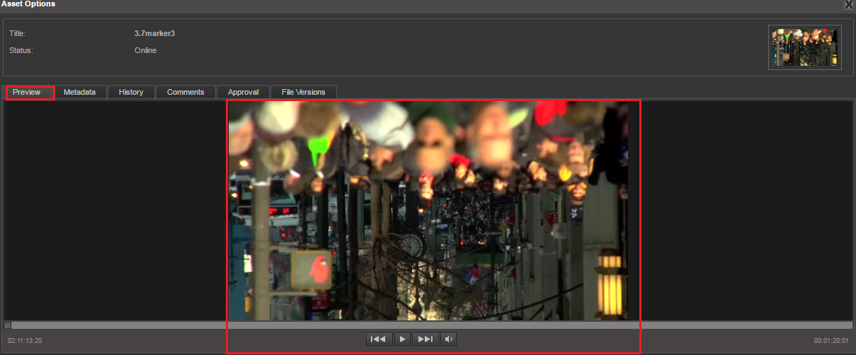

Figure 55- Asset options window: Preview tab
    - Metadata tab: Under metadata tab, you can see all the metadata details of an asset like Info, Embedded metadata, Custom metadata, and tags under different fields. They also have the option to edit metadata details of an asset.

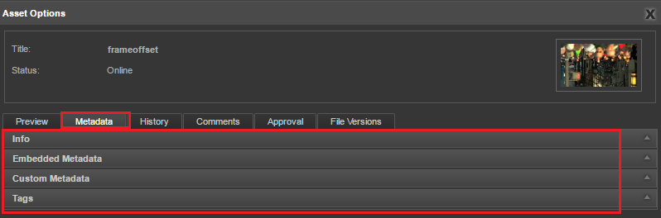

Figure 56- Asset Options window: Metadata tab

    - History tab: History tab displays the asset details and the entire history of various actions performed on any asset. You can see the details like Action Performed, Date of Action, User Name and id of the user who performed the action.

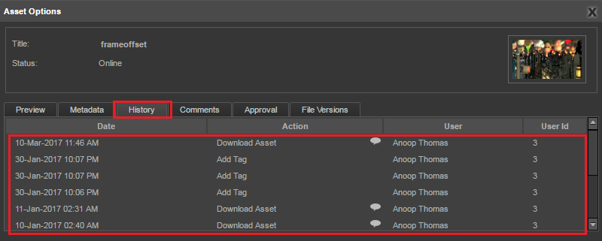

Figure 57- Asset Options window: History tab

    - Comments tab: This tab displays the user name, comment written by the user and the date when the comment was written. You can view all the comments written on different eMAM interfaces.

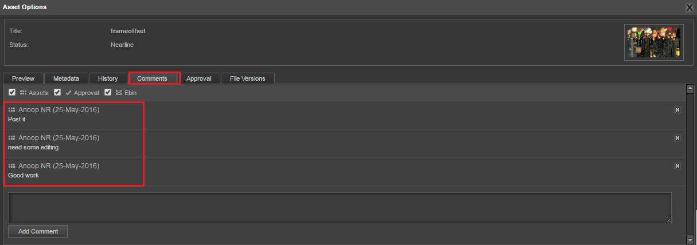

Figure 58- Asset Options window: Comments tab

    - Approval Tab: Users may require assets to be approved by another person, internal or external to the organization. Under Approval tab, you can send the assets for approval to another eMAM user (internal approval) or externally as a link to someone who has no access to eMAM (external approval).
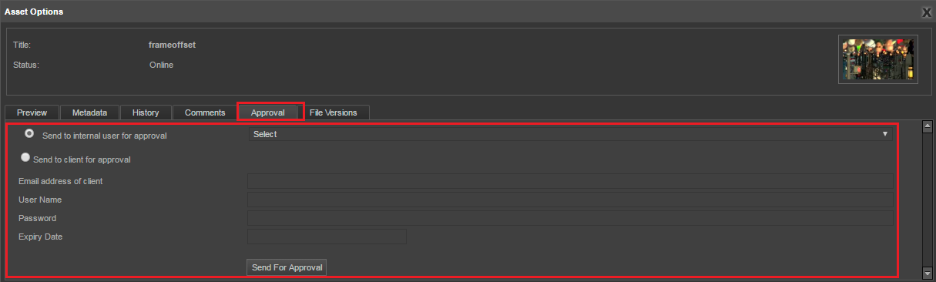

Figure 59- Asset Options window: Approval tab

    - File versions: File versions tab displays all the different versions created for the same asset. Therefore, you have option to select any version you want.
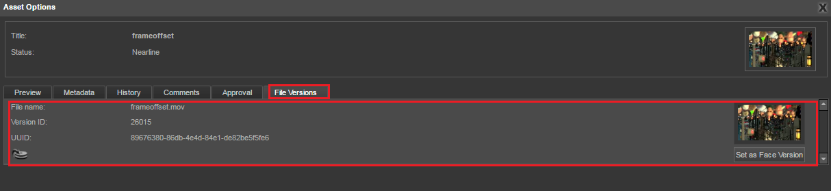

Figure 60- Asset Options window: File versions tab

Get Help
For any more information or assistance, please contact support@emamonline.com

Table of Figures

Figure 1- Select Download from Project menu options. 5

Figure 2- Select Download from Category menu options 5

Figure 3- Select Download from eBIN widget menu 6

Figure 4- Download DeskLink: Windows 64 bit 6

Figure 5- Run the downloaded file to install DeskLink 7

Figure 6- Launch DeskLink 10

Figure 7- DeskLink: Key in Gateway and Director URL 10

Figure 8- DeskLink: Login page 10

Figure 9-Select Unit 11

Figure 10-DeskLink home page 11

Figure 11- DeskLink home page overview 12

Figure 12- Archive-Restore status window for Archive 12

Figure 13- Archive-Restore status window for Restore 13

Figure 14-Search bar 13

Figure 15- Projects Tab 13

Figure 16- Categories Tab 13

Figure 17- Assets Tab 14

Figure 18- DeskLink download history window 14

Figure 19- Download from Project, Category and eBIN widget 15

Figure 20- DeskLink app download page (automatically closes after 20 secs) 16

Figure 21- Use Download button for download of assets under Projects, Categories and Assets tab. 16

Figure 22- DeskLink download page to choose download location 17

Figure 23- Browse and choose destination for download 17

Figure 24- DeskLink: Download in Progress 18

Figure 25: eMAM Download Manager- Download complete message 18

Figure 26- error message when asset download fails 18

Figure 27- DeskLink: History tab 19

Figure 28- Confirmation box before deletion 19

Figure 29- Message displayed when all the assets are deleted from a location. 20

Figure 30- Multiple download windows 20

Figure 31- Upload tab to upload assets to eMAM 21

Figure 32- Upload- Adding files from local machine 21

Figure 33- Upload- Adding folders from local machine 22

Figure 34-Asset metadata window 22

Figure 35- Files added for Upload 23

Figure 36- Message box 23

Figure 37- DeskLink: Upload in progress 24

Figure 38- DeskLink: Upload successful message 24

Figure 39-DeskLink: Monitor Dashboard for ingest progress. 24

Figure 40- DeskLink: Home page 25

Figure 41- Archive/Restore selected project 26

Figure 42- Archive status 26

Figure 43- Restore status 26

Figure 44- Archive Restore status 27

Figure 45- DeskLink Dashboard tab 27

Figure 46- Settings icon 29

Figure 47- Purge tab 29

Figure 48- DeskLink Projects tab 30

Figure 49- DeskLink Categories tab 30

Figure 50- DeskLink Assets tab 31

Figure 51- Search with auto populate option 32

Figure 52- Search option to clear search results 33

Figure 53- Folder view of projects 33

Figure 54- DeskLink Asset options window 34

Figure 55- Asset options window: Preview tab 34

Figure 56- Asset Options window: Metadata tab 35

Figure 57- Asset Options window: History tab 35

Figure 58- Asset Options window: Comments tab 36

Figure 59- Asset Options window: Approval tab 36

Figure 60- Asset Options window: File versions tab 36

