eMAM App Manager
eMAM Version 5.1
April 2019

Notice
The content in this document represents the current view of Empress Media Asset Management, LLC as of the date of publication. As Empress responds continually to the changing market conditions, this document should not be interpreted as a commitment on the part of Empress. Empress cannot guarantee the accuracy of any information presented after the date of publication.
Empress is a US registered trademark of Empress Media Inc. and is used by permission. eMAM logos are US registered trademarks of Empress Media Asset Management, LLC.
Information in this document is subject to change without notice.
Contents
Introduction 3
Installation 3
A. Download App Manager 3
1. From eMAM Director> My Account page 3
Windows 4
Mac 5
2. From panels download.htm page 5
Windows 6
Mac 6
B. Install eMAM App Manager Setup 7
Windows 7
Mac 9
Launch eMAM App Manager 9
Functions 11
1. Install 11
2. Update 12
3. Remove 14
Get Help 14

Introduction
eMAM App Manager is a single desktop app to manage the extension panels for Adobe Creative Cloud applications such as Adobe Premiere Pro, Adobe After Effects, Adobe Photoshop, Adobe Illustrator, Adobe InDesign and Adobe Media Encoder. App Manager app can be easily downloaded and installed from the panels download.htm page or from the Director> My Account page.
Using App Manager, you can control the installation, version upgrade and removal of the extensions in the Adobe Creative Cloud Applications. Just connect to the server and click on Install or Remove button of the Adobe CC applications, to either install or remove the extension panels. App Manager also monitors the application upgrade and notifies you (with an Update button) if there is a new upgrade available for any of its Adobe CC applications.

Installation
With eMAM Version 5.1, you can easily install extension panels for Adobe applications using a sing desktop app- App Manager.

Download App Manager
You can download eMAM App Manager setup file from any of the below locations :
- From eMAM Director> My Account page.
- From panel download.htm page

From eMAM Director> My Account page
Download eMAM App Manager directly from the eMAM Director Interface following the steps below:
- Login to eMAM Director interface. Go to the green radial Settings button and then click on My Account.
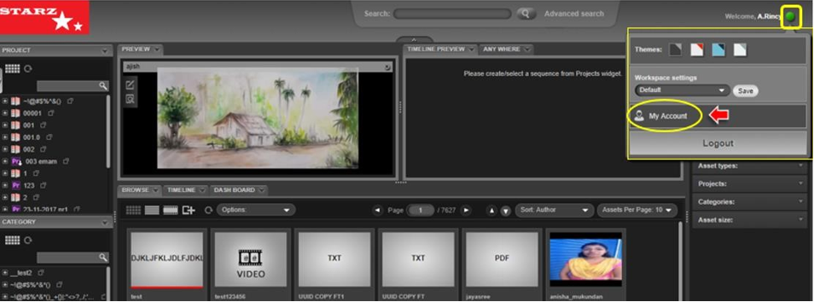
- A new window opens up for My Account. On the left-hand side, click on Apps tab.
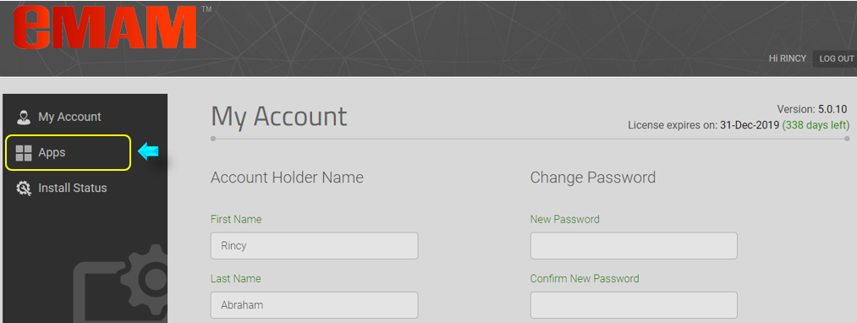

- Click on the App Manager icon and based on your machine type, click on Windows or Mac button to download the eMAM App Manager Set Up file.
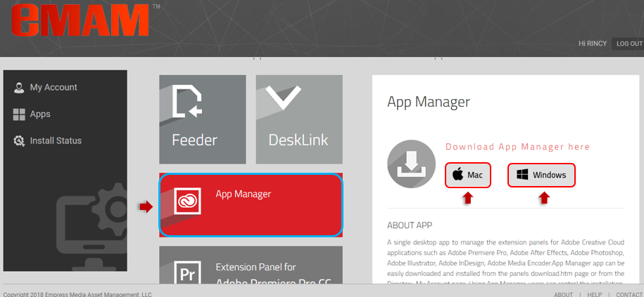

Windows

- Click on Windows will download App Manager Set Up file. Once the App Manager Set Up file is downloaded on your machine, run the App Manager Set Up installer.

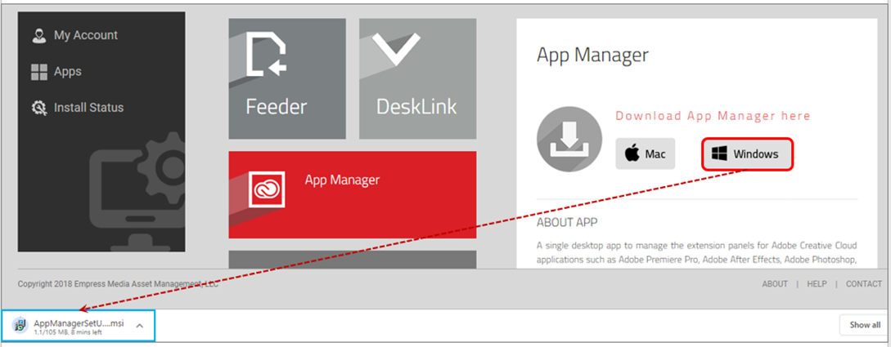

Mac
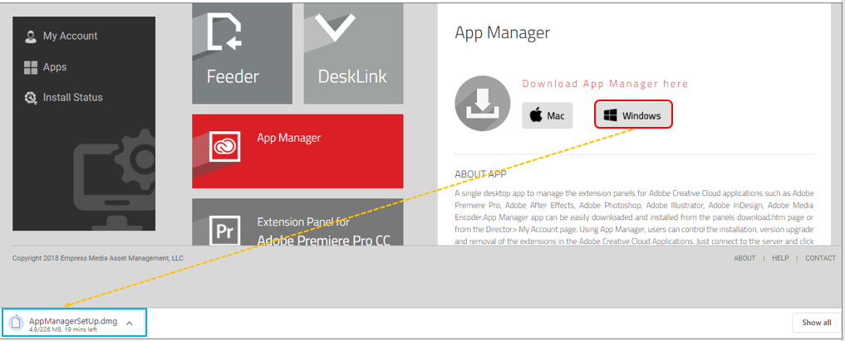

From panels download.htm page
Follow the steps below to download eMAM App Manager from panels download.htm page and install the eMAM App Manager on your machine (Windows/Mac).

- Get the URL/the name of the server running your eMAM system from your unit admin, IT department, or from the eMAM support team, to insert it into the URL below. This page lists the latest panel for all the Adobe eMAM apps (InDesign, InDesign, After Effects, InDesign, InDesign, Media Encoder)
http://eMAMServerName/eMAMDirector/Panels/download.htm
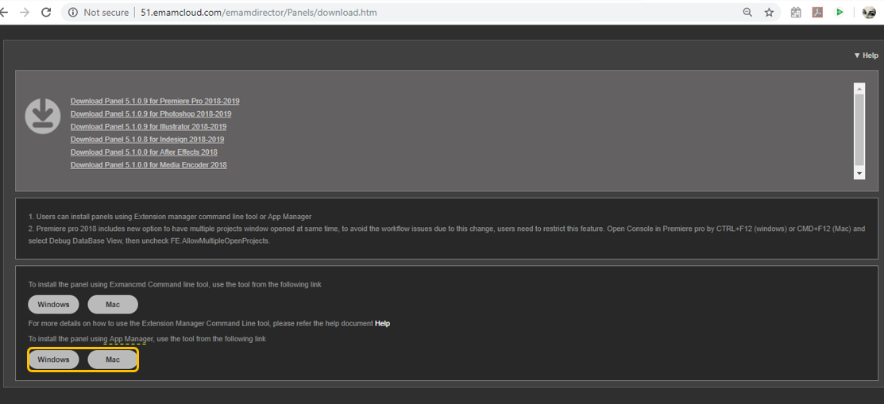
- Based on the type of your machine, click on Windows or Mac button to download App Manager Set Up file.

Windows
- Click on the Windows button to download the eMAM App Manager Set Up file on your Windows machine.

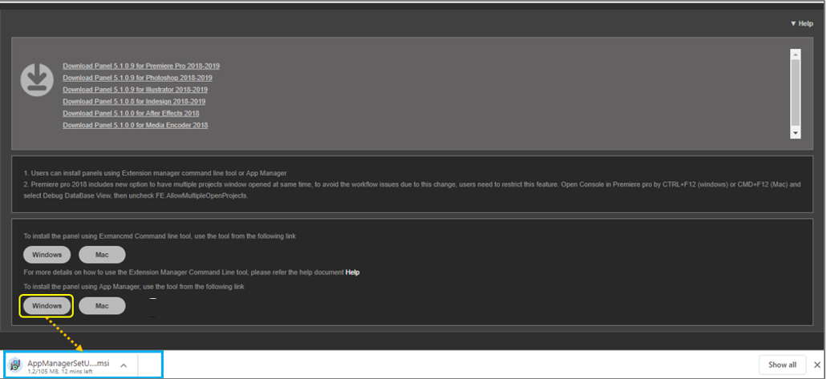

Mac
- Click on the Mac button to download the eMAM App Manager Set Up file on your Mac machine.
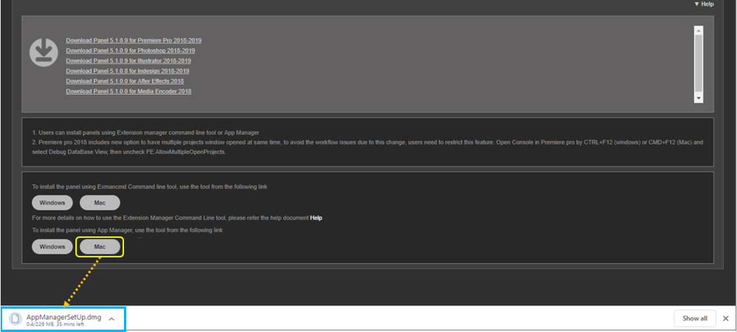

Install eMAM App Manager Setup

Windows
  - Once the App Manager Set Up file is downloaded on your machine, run the App Manager Set Up installer.
  - App Manager Set Up Wizard window opens up. Click on “Next”. Follow the instructions to complete the installation process.
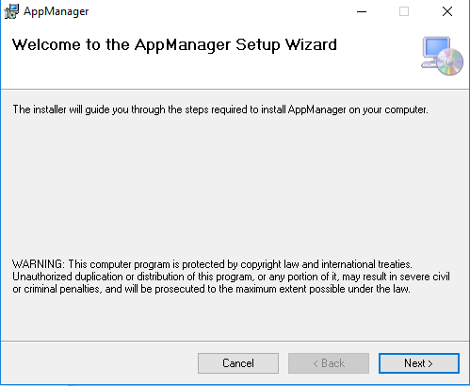

  - Click on “Next”.
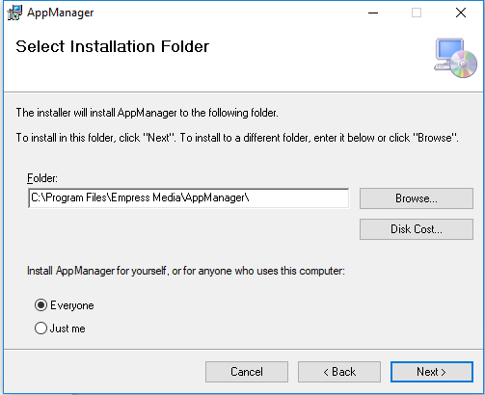

  - To confirm installation, click on “Next”.
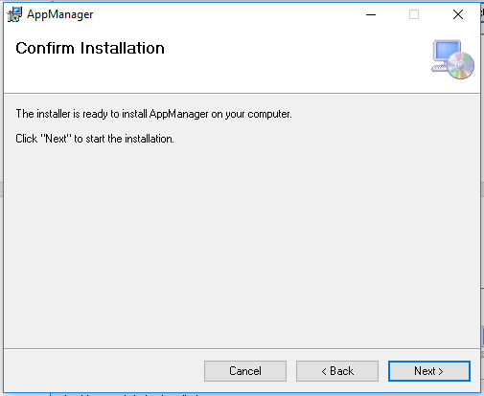
  - Now confirm installation in your machine by clicking “Yes”. Installation progress bar appears.

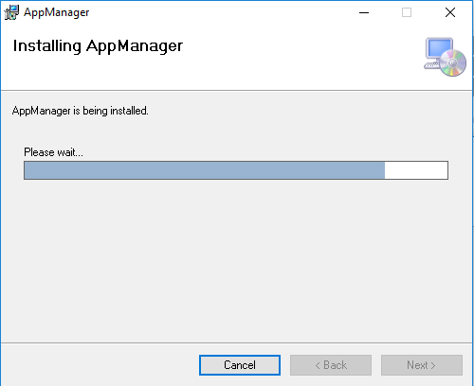

  - Click on the “Close” button after the installation is complete.
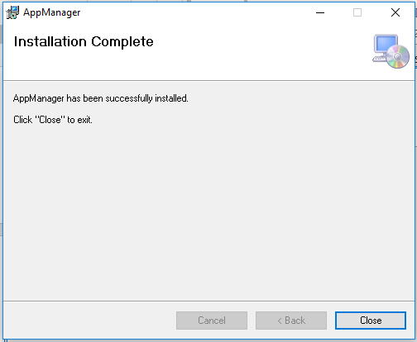

  - eMAM App Manager gets installed on your machine and you can see the below icon on your desktop.

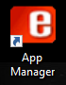

Mac
Follow the below instructions for a Mac machine:
- Once the App Manager Setup file is downloaded on your Mac machine, run the AppManagerSetUp.dmg.

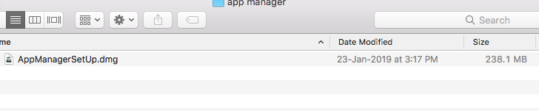

- AppManagerSetup helper app will open up with App manager icon.

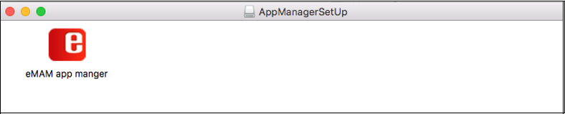

Launch eMAM App Manager
- Click on the eMAM App Manager icon on your desktop to launch it and then click on “Start Setup” button.

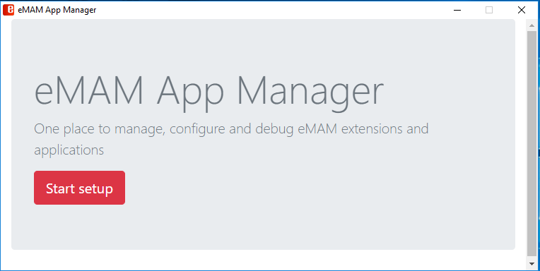

- Enter eMAM server details and click on “Save & Continue” button.

- You can see a list of Adobe CC applications like Adobe Premiere Pro, Adobe After Effects, Adobe Photoshop, Adobe Illustrator, Adobe InDesign and Adobe Media Encoder. Click the Install button under the Adobe applications you wish to install.

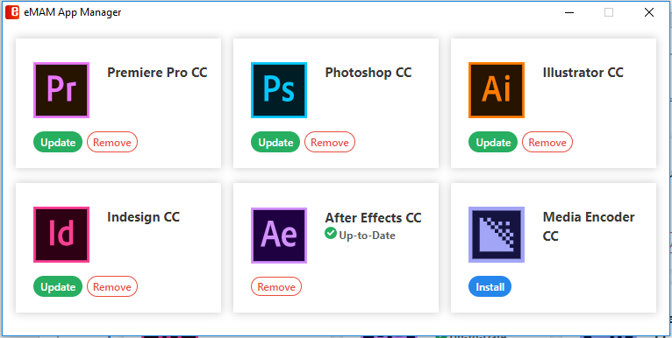

Functions
Using eMAM App Manager, you can easily perform below functions on the listed Adobe CC applications. Note: Before you proceed with any of the below functions, please ensure Adobe CC application are closed and not open in your machine.

Install
One of the main functions of eMAM App Manager is installation of eMAM extension panels for Adobe CC applications like Adobe Premiere Pro, Adobe After Effects, Adobe Photoshop, Adobe Illustrator, Adobe InDesign and Adobe Media Encoder. Each application will display Install button if it is a first-time panel installation.
Adobe Premiere Pro CC
- From the list of eMAM applications displayed, click on “Install” button for Premiere Pro CC.

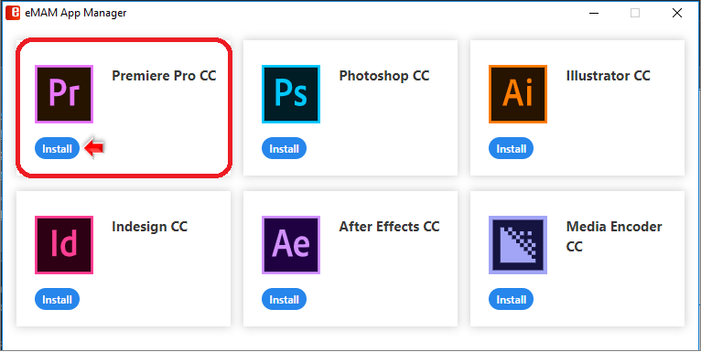
- The installation begins. After a while, you can see the Extension Manager Dashboard displaying the installation status messages. Once the installation is complete, you will see “Extension installed successfully”.

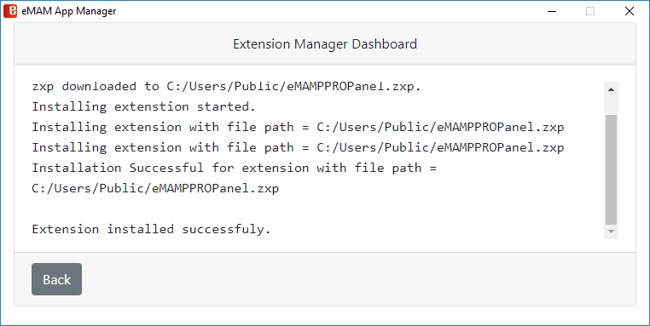

- Now launch Adobe Premiere Pro CC application from your machine and go to Windows>Extensions>eMAM. Your eMAM Premiere Panel is ready to use.
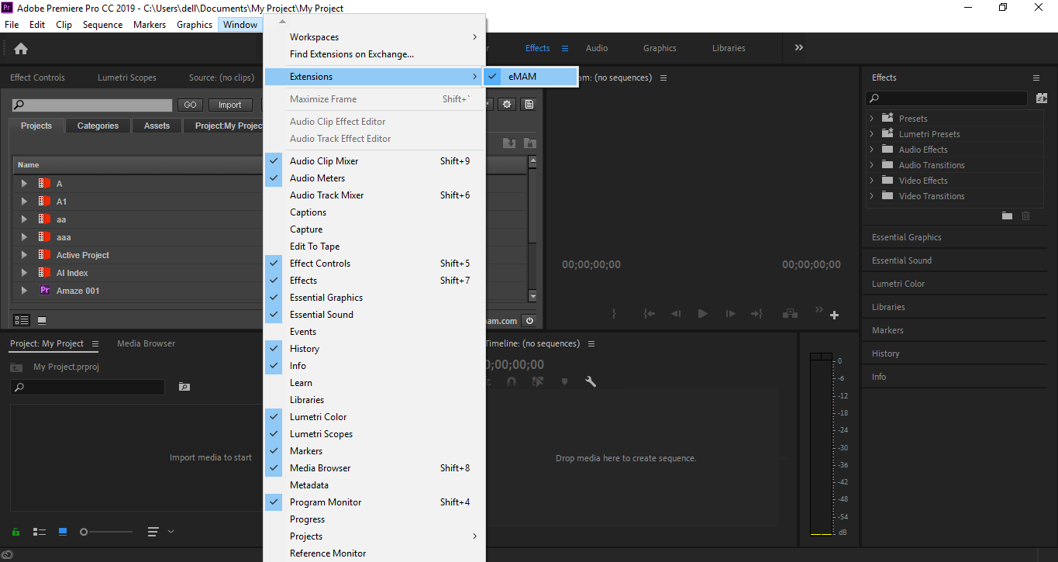

- Similarly, you can install eMAM extension panels for other Adobe CC applications by clicking on their respective Install buttons.

Update
If there a change in the eMAM Version , you will be prompted to update the eMAM extension panel to the latest version with an Update button.
- Click on the Update button displayed for the Adobe Premiere Pro CC.
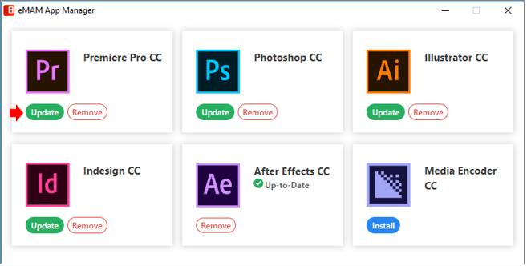
- Latest extension file gets downloaded and the Extension Manager Dashboard will display latest “Extension installed successfully” message.

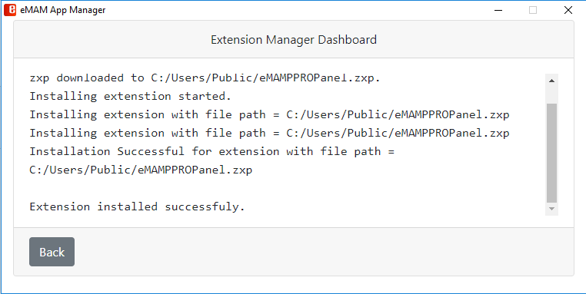

- After successful installation of the latest eMAM Premiere Panel, it will only display the Remove button with an Up-to Date icon.

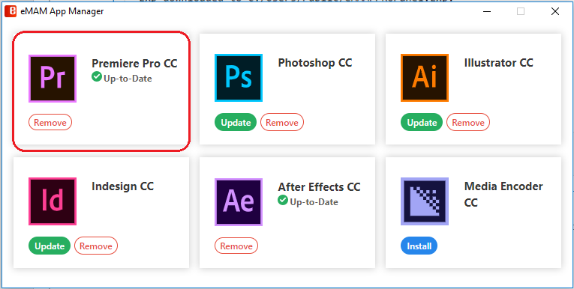

Remove
You can uninstall/remove extension panels from the Adobe application, by following below steps:
- On the Premiere Pro CC icon, click on the Remove button.

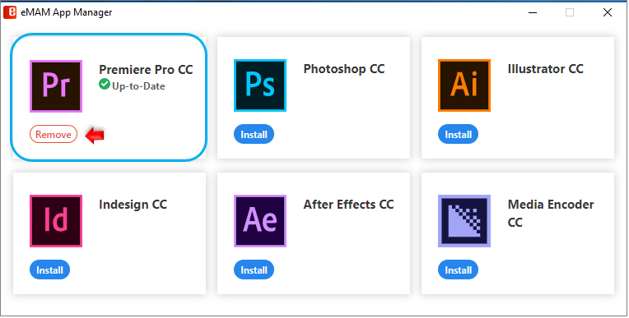
- Once the eMAM Premiere Panel extension is removed from your machine, below message appears.

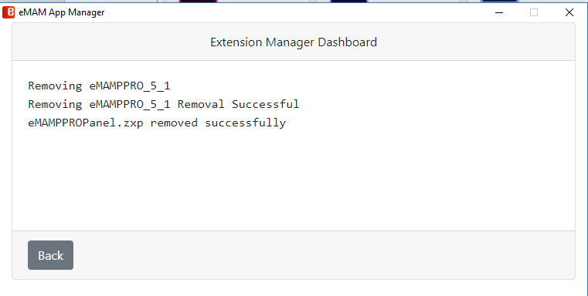

Get Help
For additional help and information, please contact eMAM Support at support@emamonline.com.

