eMAM Panel for Adobe Premiere Pro
Installation Guide
Version 5.1
Feb 2019

Notice
The content in this document represents the current view of Empress Media Asset Management, LLC as of the date of publication. As Empress responds continually to the changing market conditions, this document should not be interpreted as a commitment on the part of Empress. Empress cannot guarantee the accuracy of any information presented after the date of publication.
Empress is a US registered trademark of Empress Media Inc. and is used by permission. eMAM logos are US registered trademarks of Empress Media Asset Management, LLC.
Information in this document is subject to change without notice.

Table of Contents
Contents
Table of Contents 2
System Pre-requisites: 3
Install eMAM Premiere Panel from eMAM Director- My Account page 3
A. Using App Manager 4
Windows 4
MAC 7
B. Using Extension Manager Command Line Tool 10
Windows 11
MAC 13
Uninstall eMAM Premiere Panel 16
A. Using App Manager 16
B. Using Extension Manager Command Line Tool 17
Update eMAM Premiere Panel 17
Open eMAM Panel in Adobe Premiere Pro CC 18
Get Help 19

System Pre-requisites: Adobe recommends standard hardware and software requirements for Adobe Premiere Pro, which is the same for the eMAM Panel. The eMAM panel is HTML5 based, so it is only supported in CC versions of Adobe Premiere Pro. Note: eMAM Version 5.1 is not supported with Adobe Premiere Pro cc 2017.
Make sure you have following set before you start the Premiere Panel installation:
- Configure the Storage profile in the Super Admin Console.
- Adobe Premiere Pro CC 2018 or above installed on your machine.

Install eMAM Premiere Panel from eMAM Director- My Account page
You can install eMAM panel for Adobe Premiere using any of the methods mentioned below:
- Using App Manager, Or
- Using Command Line Tool

- Login to eMAM Director interface. Go to the green radial Settings button and then click on My Account.
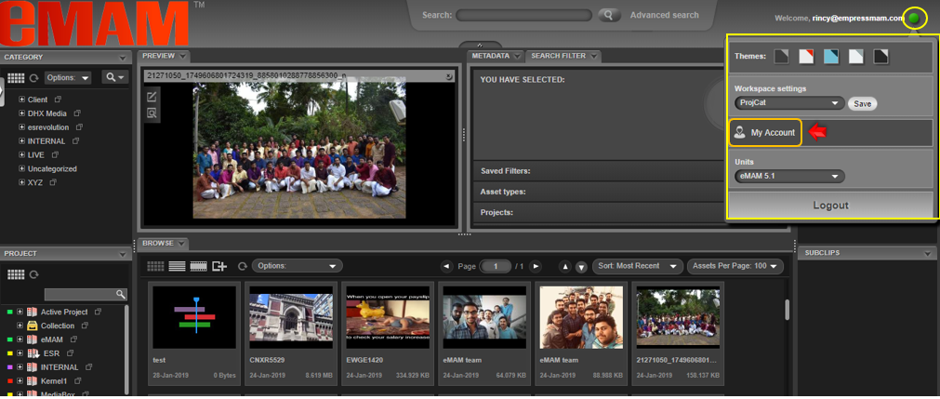
- A new window opens for My Account page. From the left menu, click on the Apps tab.
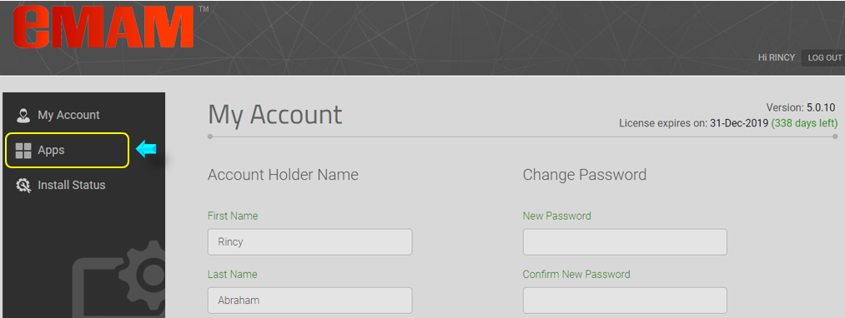
- Under the Apps tab, you can install eMAM Premiere panel using any of the below 2 methods:

- Using App Manager
Unlike earlier versions, eMAM 5.1 also uses App Manager to install eMAM Panel for Adobe Premiere Pro. Once Adobe Premiere Pro CC is installed on your machine, follow the steps mentioned below to install eMAM Panel using App Manager from the eMAM Director interface:

- Click on App Manager icon to see App Manager download options.

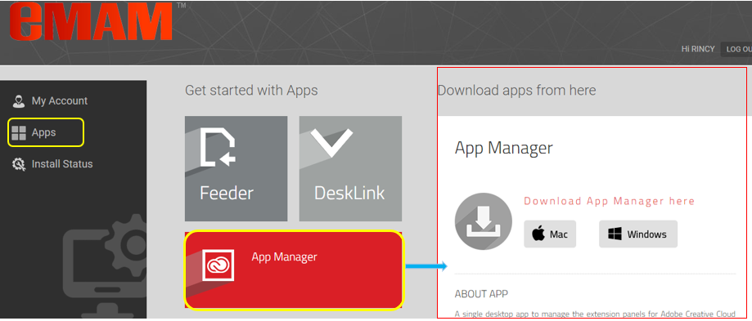

- On the right-hand side of the page, based on the type of your machine, click on the Windows or Mac button to download App Manager Setup file.

Windows
- Click on Windows to download the App Manager Setup file on your Windows machine.
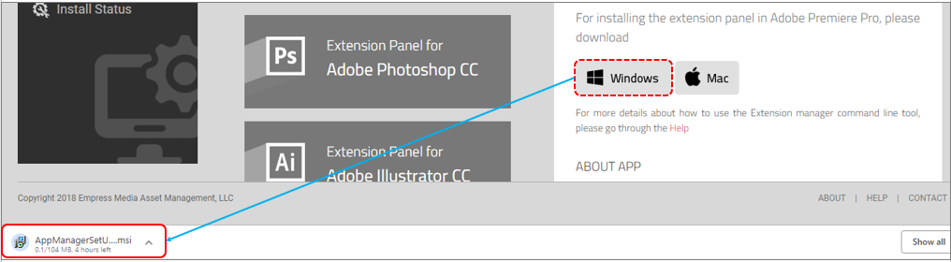

- Once the App Manager Set Up file is downloaded on your machine, run the App Manager Set Up installer.

- App Manager Set Up Wizard window opens up. Click on “Next”. Follow the instructions to complete the installation process.
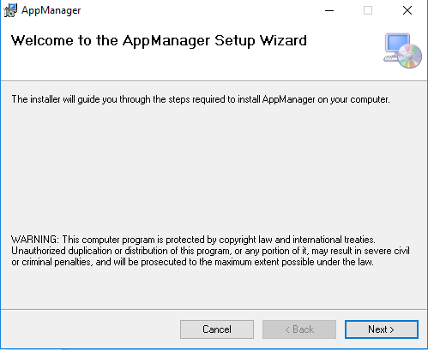

- Click on “Next”.
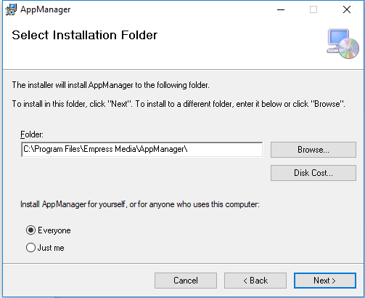
- To confirm installation, click on “Next”.
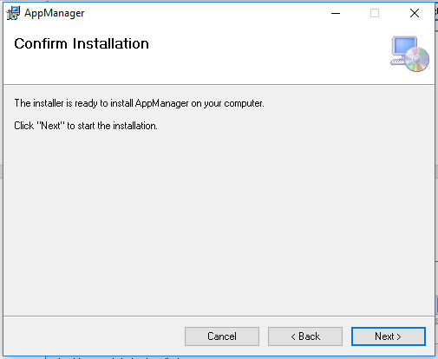

- Now confirm installation on your machine by clicking “Yes”. Installation progress bar appears.

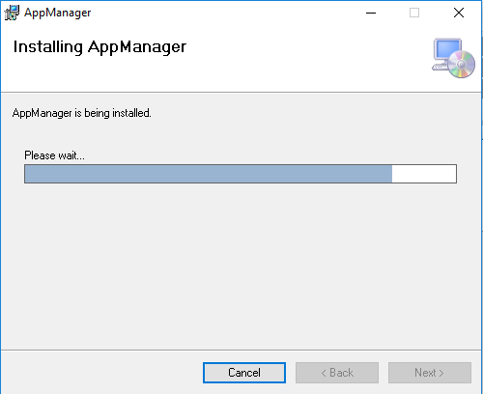

- Click on the “Close” button after the installation is complete.

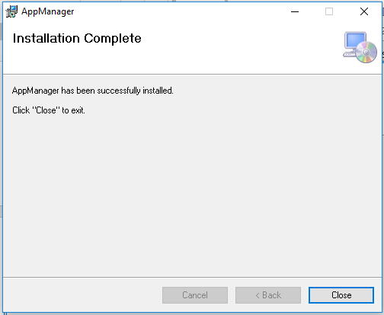

- The App Manager is now installed on your Windows machine and you can see the below icon on your desktop.

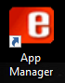

MAC
- Click on Mac button to download the App Manager Set Up file on your Mac machine.
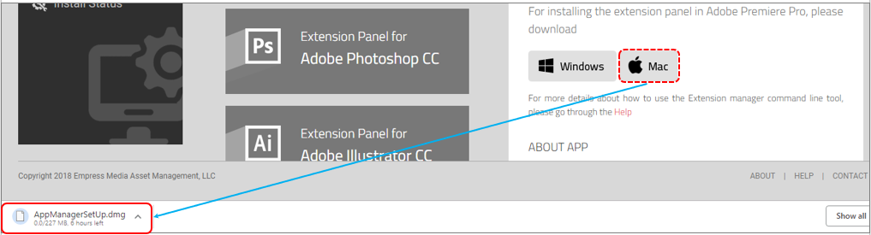

- Once the App Manager Setup file is downloaded on your machine, run the AppManagerSetUp.dmg.
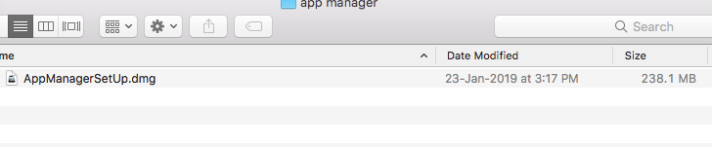

- AppManagerSetup helper app will open up with App manager icon.

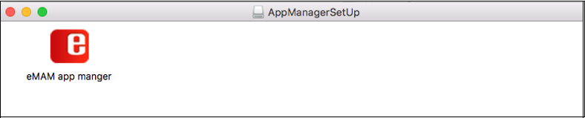
- To launch App Manager, double click on the App Manager icon on your desktop and then click on “Start Setup”.
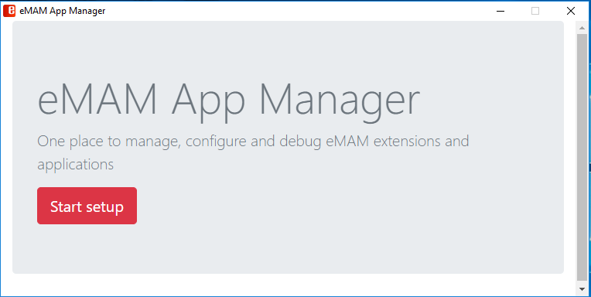

- Enter eMAM server details and click on “Save & Continue”.

- From the list of Adobe applications displayed, click on “Install” for Premiere Pro CC.

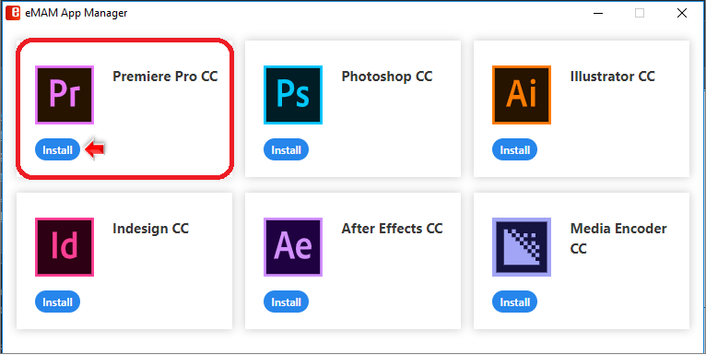

- Installation begins. You can see the Extension Manager Dashboard for installation messages. Once the installation is complete, you will see “Extension installed successfully”.

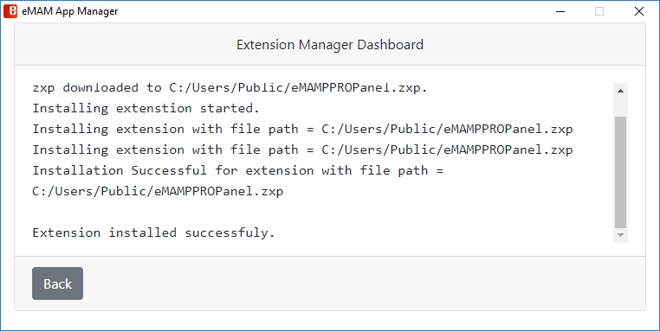
- Using Extension Manager Command Line Tool

- Under the Apps tab, scroll down and click on Extension Panel for Adobe Premiere Pro CC icon.
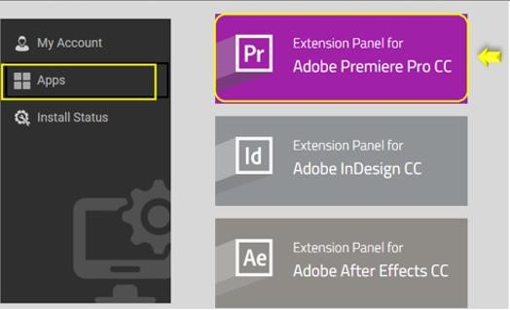

- Then on the right-hand side of the page, click on the Download Premiere Panel. Based on the type of your machine, click on the MAC or Windows to download Extension Manager Command Line tool. Click on Help to refer to panel installation steps.
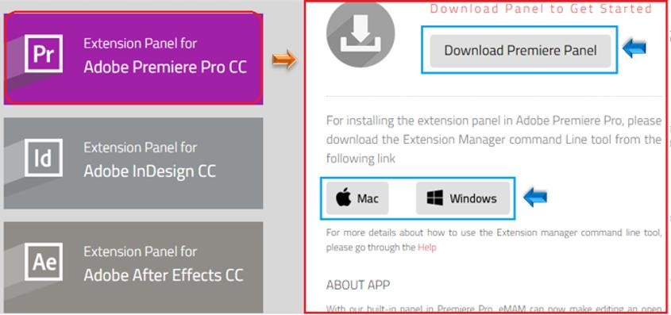

Windows
- Click on the Download Premiere Panel and then on the Windows to download the Extension Manager Command Line tool zip file.

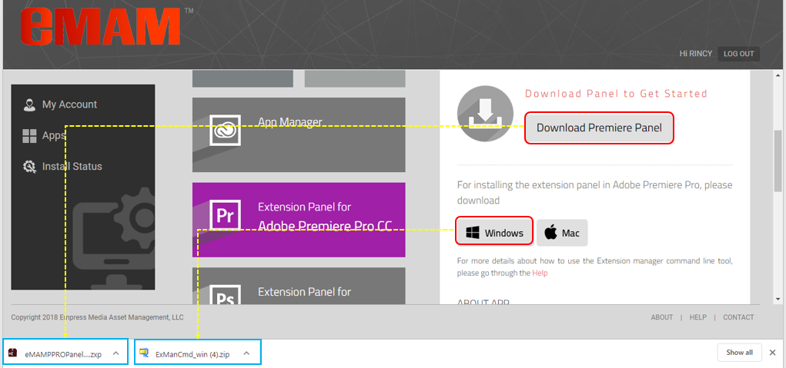

- Go to the ExManCmd_win zip file downloaded location and extract the contents from the downloaded zip.

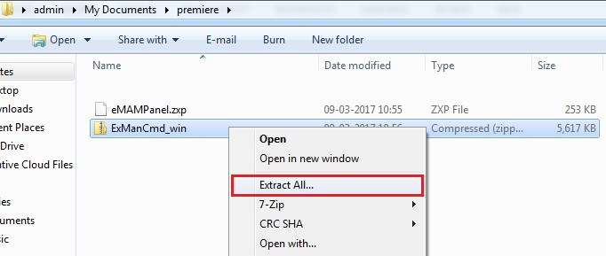

- Copy the ExManCmd_win in Windows to any system location. Press SHIFT+ mouse right click and select “Open command window here”.

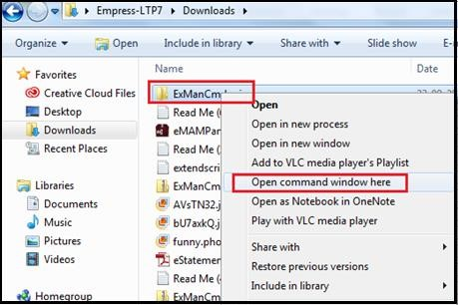

- The Cmd.exe (Command Prompt) window opens up.

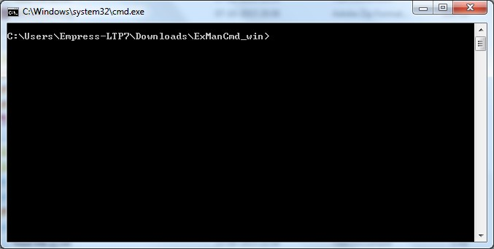

- Type exmancmd"space"/install"space" and drag and drop the eMAMPanel.zip file. The command should look like this: ExManCmd /install eMAMPanel.zxp. Press Enter.

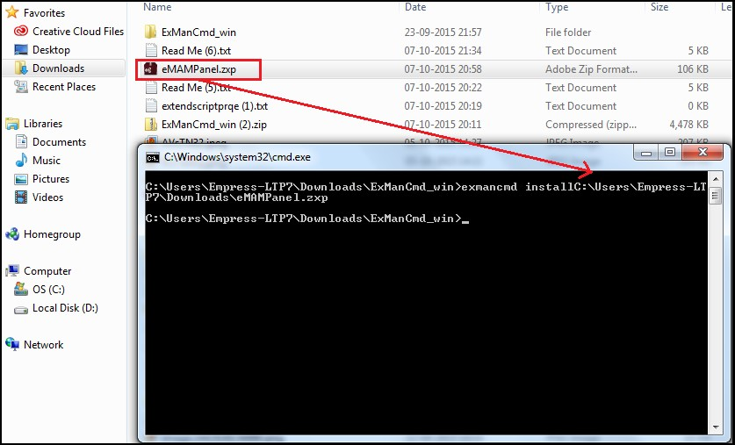

- The eMAM Panel is now successfully installed on your Windows machine and ready for use.
MAC
- Click on Download Premiere Panel and Mac button.
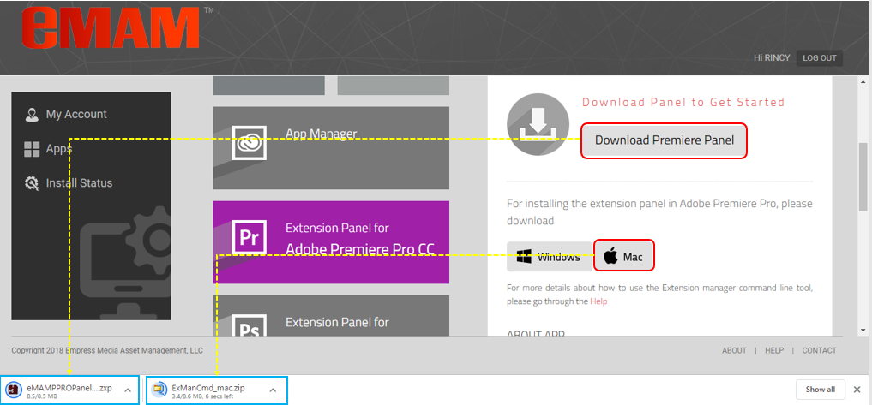

- Copy ExManCmd_mac to the Desktop.
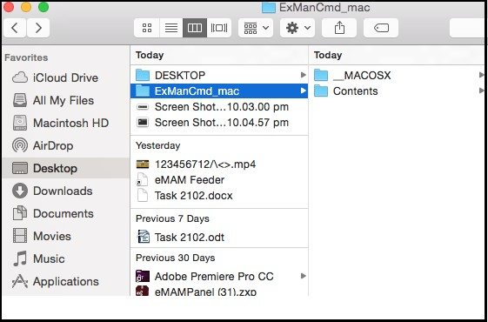

- Copy the eMAM panel.zip file to the ExManCmd_mac folder.

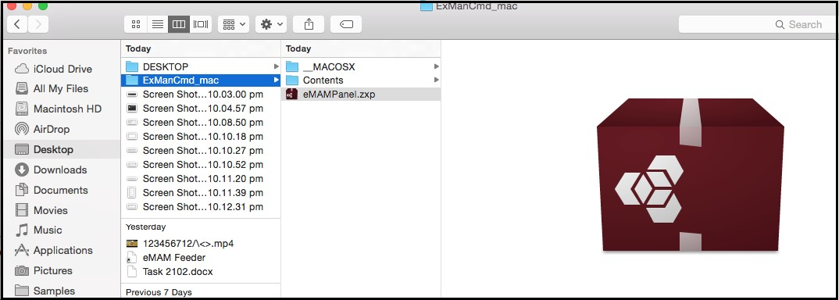

- Open the Terminal application.
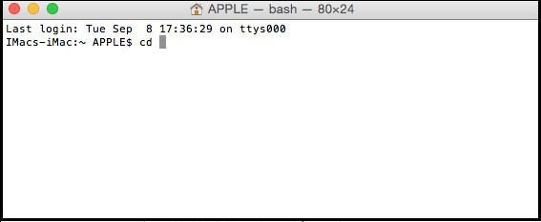

- Go to ExManCmd_mac > Contents > MacOS folder.

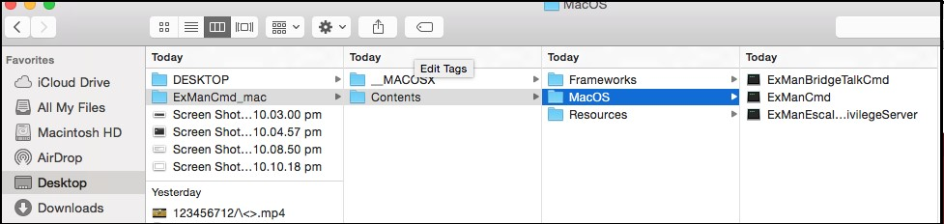

- Type ‘cd’ and ‘space’ in Terminal and drag and drop the MacOS folder after space to terminal. The command should look like this:
cd /Users/APPLE/Desktop/ExManCmd_mac/Contents/MacOS
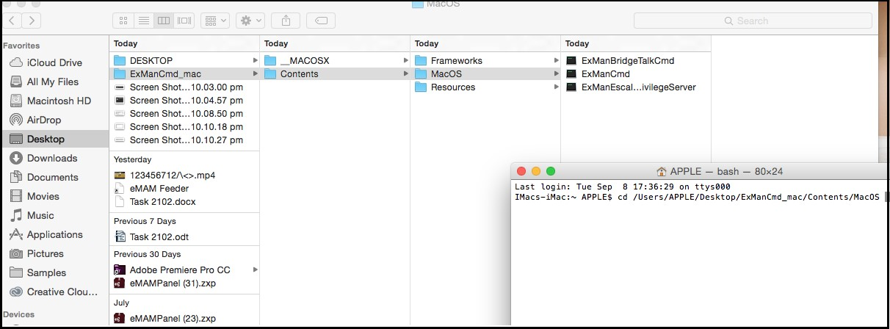

- Use the ExManCmd command to install panel.
./ExManCmd --install eMAMPanel.zxp
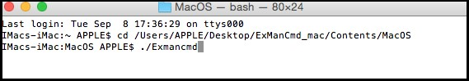

Or, to install eMAM Panel for all users, use—install_for_all and drag and drop the eMAMpanel.zxp file after a space.
./ExManCmd –install_for_all eMAMPanel.zxp
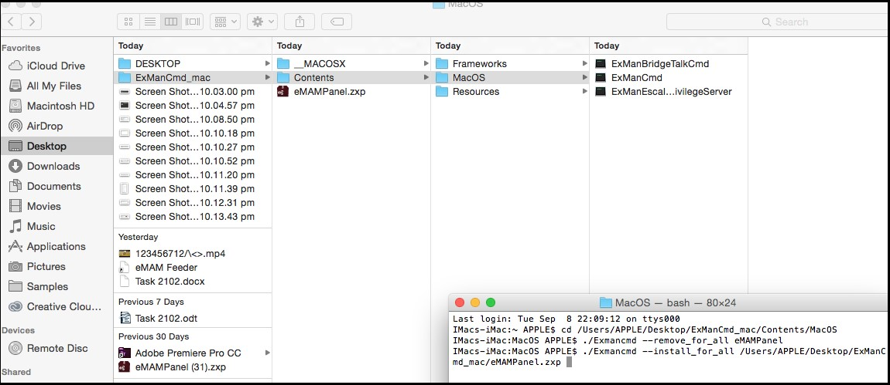

- Type in the Admin credentials.

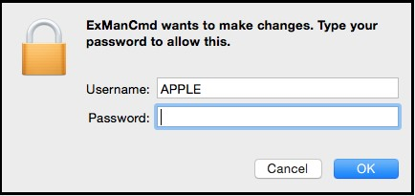

- A successful installation message will be shown, and your MAC machine is ready for use.

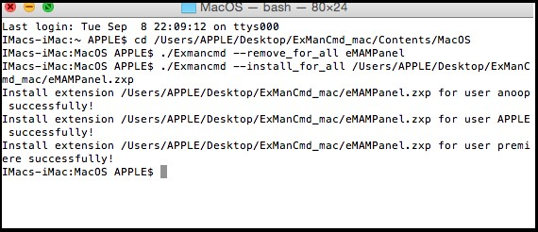
Uninstall eMAM Premiere Panel
Follow the steps mentioned below to uninstall eMAM Premiere Panel 5.1 version from any Window machine:

Using App Manager
- Click on App Manager icon on the desktop to launch it and then click on Start Setup.
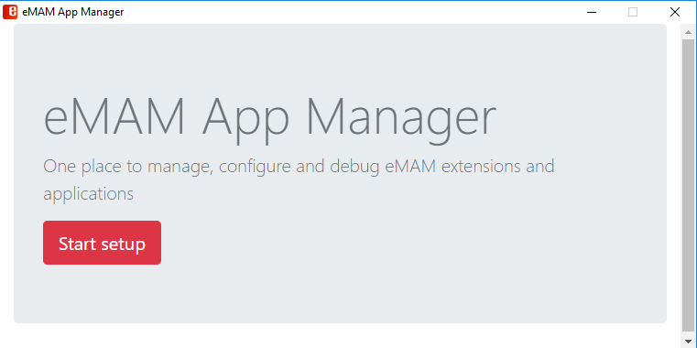

- Enter eMAM server details and click on Save & Continue.
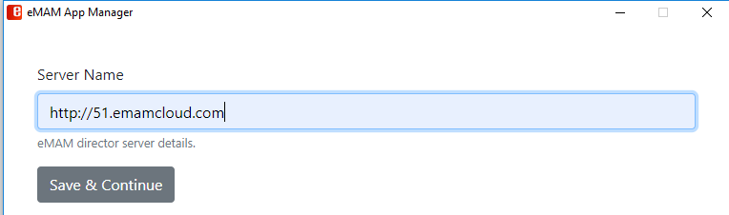

- On the Premiere Pro CC icon, click on Remove.
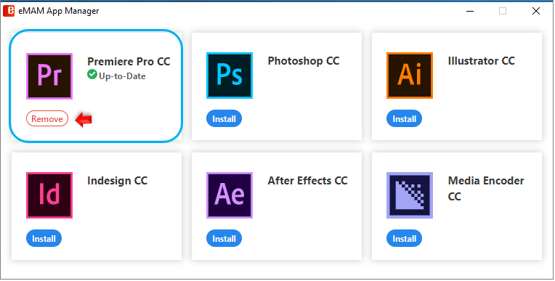

- Once the eMAM Premiere Panel extension is removed from your machine, below message appears.
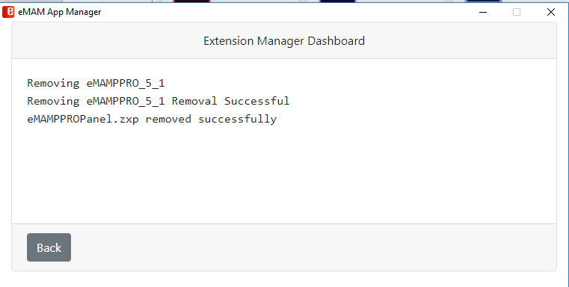

Using Extension Manager Command Line Tool
To un install eMAM Premiere Panel 5.0 version from any Window machine:
- Use ExManCmd /remove eMAM_5 to remove eMAM 5.0 Panel and press Enter.
- To remove eMAM Panel for all users, use ExManCmd /remove_for_all eMAM_5 and press Enter.

Note: To remove/uninstall eMAM Premiere Panel version 3.8, use ExManCmd /remove eMAM

Update eMAM Premiere Panel
If there is a new eMAM version upgrade for any of the Adobe eMAM panels, App manager will automatically detect and will display an option to update to the latest version. Just click on the Update button to update the eMAM Panel to the latest version
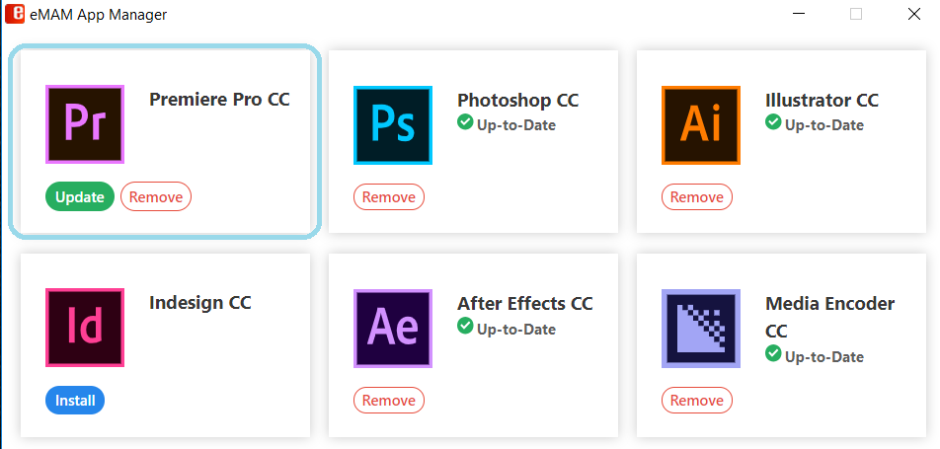
Open eMAM Panel in Adobe Premiere Pro CC
Follow the steps below to open eMAM Panel in Adobe Premiere Pro CC.

- Launch Adobe Premiere Pro CC 2019 and create a new project or open an existing project.

- In Adobe Premiere Pro top menu, go to Windows>>Extensions>>eMAM and open the eMAM Panel.
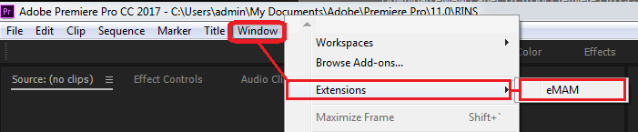

- Dock or float the eMAM Panel window in the Premiere Pro application. Enter eMAM server IP/DNS name- Replace the default server details with your eMAM server name and click on OK. For e.g.: http://servername/
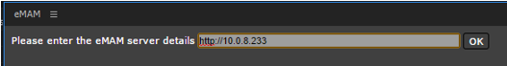

- Login to the eMAM Premiere Panel, using the eMAM login credentials provided by your eMAM Unit administrator and click on GO.
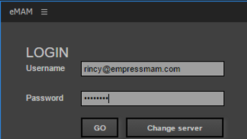

- If a user profile is associated with multiple units, you will be asked to choose a unit at login. After the first login, it will use the same credentials to login automatically for all subsequent logins. You can click on the Logout button if you want to remove the credentials for the next login.
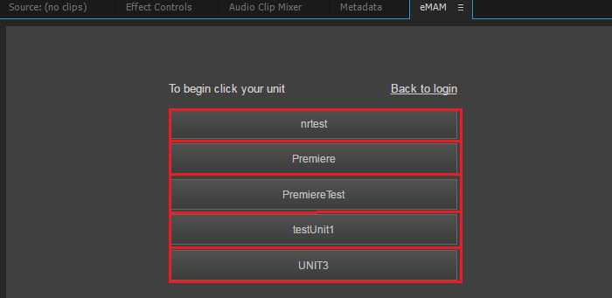

- eMAM Panel opens in Adobe Premiere Pro as shown below and is ready for use.
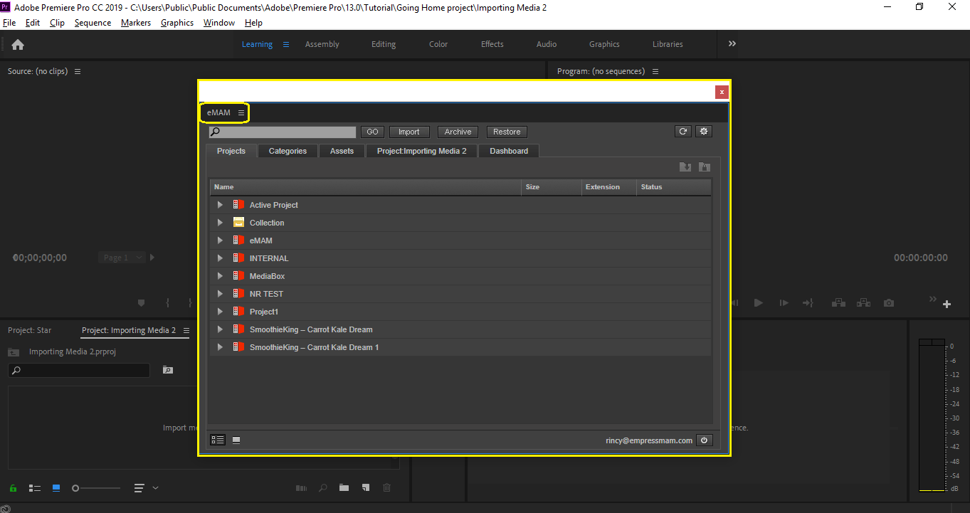

Get Help
For more information and assistance, please contact eMAM Support at support@emamonline.com.

