

|  |
| --- |
| Server Spec Guide  eMAM Enterprise 5.1 |
|  |
|  |
|  |
|  |
|  |
|  |
|  |
|  |
|  |
|  |
| Copyright © 2019 Empress Media Asset Management, LLC |



Contents

1. Introduction 3

2. eMAM Enterprise 4

2.1 eMAM Database Cluster 4

2.2 eMAM Web Cluster 4

2.3 eMAM Application Server 4

2.4 Hardware specification for iSCSI SAN Storage 5

2.5 Online Storage 5

2.6 Hardware for Online Storage 5

2.7 Cloud Storage (Optional) 6

2.8 eMAM Disaster Recovery (DR) System 6

2.9 Archive Appliance / Archive Server 6

2.10 Transcode Appliance / Transcode Server 6

3. On Premise – eMAM Enterprise 7

3.1 eMAM Enterprise – On Premise Network Diagram 9

4. Virtual Machine – eMAM Enterprise 10

5. Cloud – eMAM Enterprise 12

5.1 eMAM Enterprise – Cloud server info 14

5.2 eMAM Enterprise – Important Cloud Services 15

5.3 eMAM Enterprise – Other Cloud Services 16

5.4 eMAM Enterprise – Cloud Network Diagram 17

6. Firewall Ports 18

7. Redundancy 19

7.1 Redundant eMAM Server for Failover and Disaster Recovery (DR) 19

7.2 Some basic requirement & guidelines for failover system - 20

7.3 eMAM Redundant Server License 21

7.4 Options for 3rd Party Failover 21

# Introduction

eMAM is an all-in-one, web-based Digital Asset Management (DAM) software system designed to organize, share, and collaborate digitized information such as audios, videos, images, and documents. Empress has taken a ground-breaking approach to create a flexible, feature-rich, and modular digital asset management platform to meet asset management requirements of individuals, as well as major enterprises. As per our continued endeavor to increase our feature offerings, we have released our eMAM 5.1, from our current version of eMAM 5.0.

Empress can offer basic hardware specs for the different packages and platforms, but it is ultimately up to the Reseller/ SI or cloud vendor to finetune the hardware specs with their offerings and the customer’s requirements. This document is meant as a starting point guide.



|  |  |
| --- | --- |
| eMAM Enterprise |  |

## 2.1 eMAM Database Cluster

This consists of two servers loaded with Microsoft SQL Server 2016, 2017 or 2019 to host eMAM database. Database clustering can be achieved with two nodes of identical server hardware and SAN storage. Microsoft SQL Server 2016, 2017 or 2019 Enterprise, Microsoft Windows Server 2016 or 2019 failover clustering feature and the Microsoft Distributed Transaction Coordinator (*MSDTC*) should be installed in the cluster nodes to achieve database automatic failover. eMAM database and transaction log recommended to be placed in separate RAID arrays in the SAN storage.

eMAM Application components will be pointed to the clustered instance of SQL server. By default, SQL Server and eMAM Database executables will be running from node 1 of the database cluster (Active). In case of any failure with node1, database services will be automatically failover to node 2. This failure will not be visible to the end users other than a few seconds of service interruption in the eMAM user interfaces during the failover process.

** Please note – eMAM uses windows service users that must have read/write/delete access to the Storage. This in most cases requires the same user is also a valid user on the storage.

** Please note all failover configurations are the responsibility of the Customer, Reseller/SI.

## 2.2 eMAM Web Cluster

eMAM Gateway, eMAM Director, and eMAM Mobile will be running from two server nodes that are configured to perform automatic failover and network load balancing. The Microsoft Network Load Balancing (NLB) feature installed in the server nodes will distribute the web requests coming from end users to different nodes based on the availability and workload. If any of the server nodes fail, the other server node will fulfill the request coming from the end users. Whenever, there is an increase in load, we can easily add more nodes into eMAM web server cluster and distribute the load.

The other option would be a 3rd party Load Balancer sitting in front of the 2 eMAM Web/Gateway nodes. The load Balancer will detect and direct the traffic to the least used eMAM gateway and if one node goes down it will direct all traffic to the other node.

** Please note all failover configurations are the responsibility of the Customer, Reseller/SI.

## 2.3 eMAM Application Server

This consists of one server installed with transcoding software, eMAM Delivery Service, eMAM Cloud Connector, eMAM Ingest Service and eMAM Archive. The eMAM Application server is mainly responsible for making low resolution copy of the source file for web-based preview, synchronize the content in the online storage with cloud storage and archive/restore/deliver the assets. In case of any failure, we can manually bring up those services from another server. Failed jobs can be easily resubmitted from the eMAM Director Dashboard.

(This architecture will be difficult to implement as a combined direct attached / SAN storage environment because the same storage volume must be shared between application servers. NAS storage is recommended here.)

** Please note eMAM Application Server does not have failover options.

## 2.4 Hardware specification for iSCSI SAN Storage

This is the minimum requirement to build a SQL server cluster with one active node and one passive node. This storage should have at least two iSCSI connections.

* Dual storage controllers
* 15K SAS hot-pluggable hard disk drives
* At least 2TB storage (for eMAMdb, log file, tempdb and eMAM patches)

(Similar configuration of Dell EqualLogic PS4100XV)

<http://www.windowsservercatalog.com/item.aspx?idItem=c7785122-718b-2180-7eab-473f12a1dfaa&bCatID=1511>

This can be any storage provided by Customer that supports SQL Server failover clustering.

** Please note – eMAM uses windows service users that must have read/write/delete access to the Storage. This in most cases requires the same user is also a valid user on the storage.

## 2.5 Online Storage

eMAM stores the original and proxy files in an online storage for immediate access. Storage size can be determined based on the daily ingest volume and the amount of content needs to be kept in the online storage. eMAM has built in options to move the content from online storage to archive storage based on storage threshold, archive threshold (days) and other archive rules. This can be a NAS, DAS or SAN storage depends on the architecture.  In the configuration illustrated the online storage will be used for distribution media only not for the graphics archive.

** Please note – eMAM uses windows service users that must have read/write/delete access to the Storage. This in most cases requires the same user is also a valid user on the storage.

## 2.6 Hardware for Online Storage

* NAS storage that can support CIFS/SMB (Provided by Customer)
* For best performance on streaming, you may want to go with an Object Storage for proxies.

** Please note – eMAM uses windows service users that must have read/write/delete access to the Storage. This in most cases requires the same user is also a valid user on the storage.

## 2.7 Cloud Storage (Optional)

eMAM can store the content in Object Storage buckets. The eMAM Cloud connector can upload the original content and proxy files into separate cloud storage buckets. Content that exist in AWS S3 buckets can be presented through Amazon CloudFront (CDN) URL within eMAM. For example, if somebody tries to preview a video from Los Angeles, the video will be loaded from a datacenter in Los Angeles. If somebody tries to preview the same video from London, the video will be loaded from a datacenter near to London. Cloud storage can be considered as an archive storage too.

Purchase the cloud services from a cloud vendor and provide the account configuration details to eMAM implementation team. (sample cloud vendors below)

1. <http://aws.amazon.com/s3/>
2. <http://aws.amazon.com/cloudfront/>
3. <https://azure.microsoft.com/en-us/services/storage/>
4. <https://cloud.google.com/storage/>
5. [https://wasabi.com](https://wasabi.com/)

## 2.8 eMAM Disaster Recovery (DR) System

eMAM components can be installed in another server to make an offsite DR system. The database can be set up to periodically be backed up from production system to DR system. DR storage is not mandatory for eMAM if the content is stored in the cloud. Whenever there is any downtime in production environment, we can easily bring up the DR system by making the database online and perform some IP/Domain configuration changes.

## 2.9 Archive Appliance / Archive Server

This server is required to manage a robotic LTO library. eMAM Archive module will interface with the archive server/appliance to perform archive, restore and partial restore functions from LTO tapes.

<http://empressmam.com/partners.aspx>

## 2.10 Transcode Appliance / Transcode Server

This server is required to create .h264 MP4 proxy files for eMAM. eMAM Ingest and delivery modules will interface with the transcode server/appliance to perform transcodes. Transcoding is done by a 3rd party partner.

<http://empressmam.com/partners.aspx>

|  |  |
| --- | --- |
| On Premise – eMAM Enterprise |  |

The eMAM Enterprise software package consists of 2 licenses of eMAM Database, eMAM Gateway, eMAM Analytics Gateway, eMAM Director, eMAM Ingest Manager, eMAM Task Manager, eMAM Archive and eMAM Delivery Service. In eMAM Enterprise configuration, eMAM software components can be deployed in 5+ servers.

Basic Server hardware requirements for eMAM Enterprise are as follows:

|  |  |
| --- | --- |
| **Type** | **Requirement** |
| **Operating Systems &**  **Database – eMAM Database Servers** | Windows:   * Windows Server Enterprise 2016 -> Windows Server Enterprise 2019 * Microsoft SQL Server 2016, 2017 & 2019 Standard   CAL license supplied by System Integrator/Customer – *Check with Microsoft for accurate Cal counts.* |
| **eMAM Database Servers** | * 2 x Intel Six core processors (12 Cores), 2.66Ghz or higher * 32GB RAM * 2 x 146GB 15K RPM HDD on RAID1 * Additional NIC ports for iSCSI connection * 4 port Ethernet card |
| * 2 x Intel Six core processors (12 Cores), 2.66Ghz or higher * 32GB RAM * 2 x 146GB 15K RPM HDD on RAID1 * Additional NIC ports for iSCSI connection * 4 port Ethernet card |
| **eMAM Database Components** | eMAM Database (Provided by Empress) |
| **Operating Systems &**  **eMAM Web/Gateway Servers** | Windows:   * Windows Server Standard 2016 -> Windows Server Standard 2019 |
| **eMAM Web/Gateway Servers** | * 2 Intel Quad core processors (8 Cores), 2.5Ghz or higher * 8GB RAM * 2 X 146GB 10K RPM SAS HDD on RAID1 * 4 port Ethernet card |
| * 2 Intel Quad core processors (8 Cores), 2.5Ghz or higher * 8GB RAM * 2 X 146GB 10K RPM SAS HDD on RAID1 * 4 port Ethernet card |
| **eMAM Database Components** | eMAM Gateway (Provided by Empress)  eMAM Analytics Gateway (Provided by Empress)  eMAM Director (Provided by Empress) |
| **3rd Party Load Balancer in front of eMAM Web/Gateway Servers** | Optional but is best solution. (Supplied by Customer, Reseller/SI) |
| **SSL Support** | Yes –**Microsoft IIS** Certificate required  (Supplied by Customer or Reseller/SI – To be installed on Load Balancer if there is one.) |
| **Active Directory / SSO** | Integration Available |
| **Operating Systems &**  **eMAM Application Servers** | Windows:   * Windows Server Standard 2016 -> Windows Server Standard 2019 |
| **eMAM Application Servers**  (Note there is no failover) | * 2 Intel Six core processors (12 Cores), 2.66Ghz or higher * 16GB RAM * 2 X 146GB 15K RPM HDD on RAID1 * 4 X 300GB 10K RPM HDD on RAID10 (This is a high-speed temporary buffer storage for eMAM for transcoding) * 4 port Ethernet card |
| * 2 Intel Six core processors (12 Cores), 2.66Ghz or higher * 16GB RAM * 2 X 146GB 15K RPM HDD on RAID1 * 4 X 300GB 10K RPM HDD on RAID10 (This is a high-speed temporary buffer storage for eMAM for transcoding) * 4 port Ethernet card |
| **eMAM Application Components** | eMAM Ingest Manager (Provided by Empress)  eMAM Task Manager (Provided by Empress)  eMAM Delivery Service (Provided by Empress)  eMAM Archive (Provided by Empress) |
| **Microsoft Office** | Office Professional Plus 2016, 2019 (Supplied by Customer or Reseller/SI – for each server) |
| **SSL Support** | Yes – eMAM Web Uploader **Apache** Certificate required  (Supplied by Customer or Reseller/SI – for each server) |

eMAM allows user to login to the application using any standard web browser. eMAM supports two types of logins: using Active Directory login or using normal login.

## 3.1 eMAM Enterprise – On Premise Network Diagram

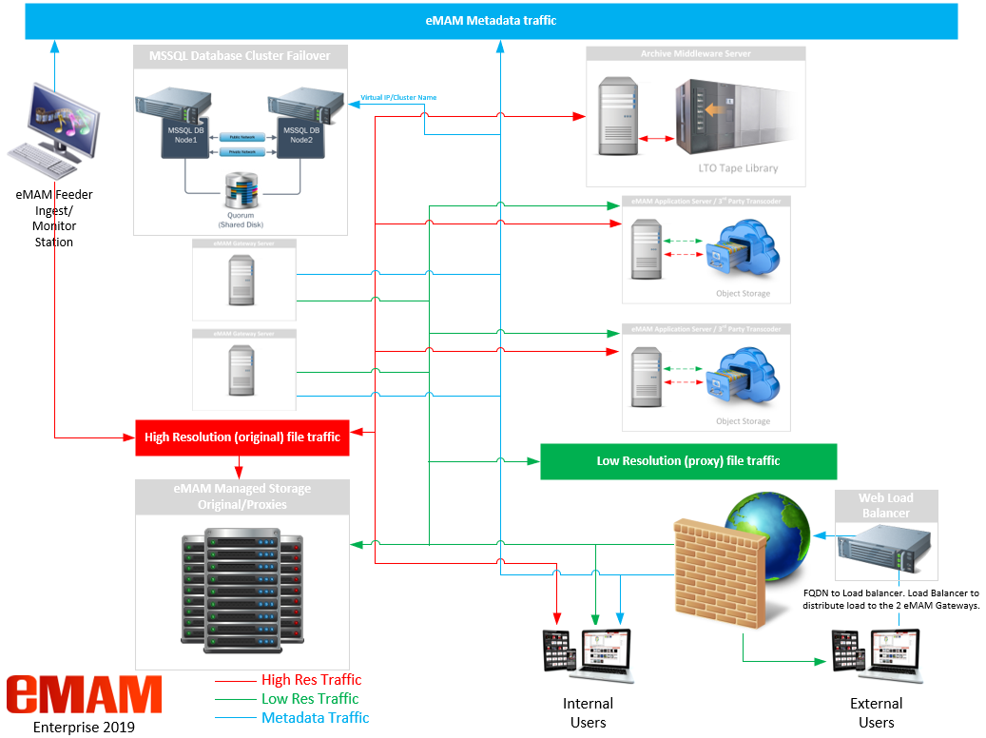

* Empress Media Asset Management is a software company concentrating on building industry leading MAM software. Through our partner eco system, we provide complete turkey solution including hardware and third-party software.

|  |  |
| --- | --- |
| Virtual Machine – eMAM Enterprise |  |

eMAM Enterprise software package consists of 2 licenses of eMAM Database, eMAM Gateway, eMAM Analytics Gateway, eMAM Director, eMAM Ingest Manager, eMAM Task Manager, eMAM Archive and eMAM Delivery Service. In eMAM Enterprise configuration, eMAM software components can be deployed in 5+ servers.

Basic Server hardware requirements for eMAM Enterprise are as follows:

|  |  |
| --- | --- |
| **Type** | **Requirement** |
| **Operating Systems &**  **Database** | Windows:   * Windows Server Enterprise 2016 -> Windows Server Enterprise 2019 * Microsoft SQL Server 2016, 2017 & 2019 Standard Edition |
| **eMAM Demo / POC Server** | **Proof of Concept Virtual Server:**   * Virtual CPU Processors: 4 * Memory: 6GB Ram * Windows 2016 or 2019 Standard Edition (Evaluation License is OK) * Please make sure the Windows operating System is installed in US ENGLISH * Please make sure the Date/Time is set to US ENGLISH * Please make sure all Windows Patches/Updates are applied. * MSSQL – 2017 or 2019 Express Edition (Express Edition for POC purposes) * Empress can install the MSSQL software as there are some pre-requisites that need to be set during the install. * OS Drive: 100GB * Separate Drives for eMAM folders - Original, Proxy, ingest (The amount of space depends on how much content you want to test with. I would suggest minimum of 500GB) |
| **eMAM VM Server** | **Database / Web Gateway VM Server:**   * CPU – Quad 2.80 GHz Intel Xeon ®E5-2680 v2 * Virtual CPU Processors: 4 * Memory: 14GB Ram * Windows 2016 or 2019 Enterprise Edition * Please make sure the Windows operating System is installed in US ENGLISH * Please make sure the Date/Time is set to US ENGLISH * Please make sure all Windows Patches/Updates are applied. * MSSQL – 2017 or 2019 Standard Edition * Empress can install the MSSQL software as there are some pre-requisites that need to be set during the install. * OS Drive: 200GB * Separate Drive (SSD preferred) for Database: 50GB * Separate Drive (SSD preferred) for TMP files: 50GB * Separate Drive (SSD preferred) for Log files: 50GB |
| **Application VM Server:**   * CPU – Quad 2.80 GHz Intel Xeon ®E5-2680 v2 * Virtual CPU Processors: 12 * Memory: 14GB Ram * Windows 2016 or 2019 Standard Edition * OS Drive: 200GB * Separate Drives for Ingest: Minimum 1TV – Depends on how much content is being uploaded. (Depending on network speed, this can sometimes be a NAS volume) * Separate drive for eMAM Original & Proxy folders. (This is typically a NAS volume) |
| **Active Directory / SSO** | Integration Available |
| **SSL Support** | Yes –**Microsoft IIS & Apache** Certificates are required  IIS Certificate to be installed on the Web Gateway, and Apache is to be installed on the eMAM Application server.  (Supplied by Customer or Reseller/SI) |
| **eMAM Database Web Gateway Components** | eMAM Database (Provided by Empress)  eMAM Gateway (Provided by Empress)  eMAM Analytics Gateway (Provided by Empress)  eMAM Director (Provided by Empress) |
| **eMAM Application Components** | eMAM Ingest Manager (Provided by Empress)  eMAM Task Manager (Provided by Empress)  eMAM Delivery Service (Provided by Empress)  eMAM Archive (Provided by Empress) |
| **Microsoft Office** | Office Professional Plus 2016, 2019 (Supplied by Customer or Reseller/SI) |

|  |  |
| --- | --- |
| Cloud – eMAM Enterprise |  |

eMAM Enterprise software package consists of eMAM Database, eMAM Gateway, eMAM Analytics Gateway, eMAM Director, eMAM Ingest Manager, eMAM Task Manager, eMAM Archive and eMAM Delivery Service. In eMAM Enterprise configuration, eMAM software components can be deployed in 5+ servers. ***Consult with the Cloud Vendor’s Solution Architect for failover server configuration.***

Basic Server hardware requirements for eMAM Enterprise are as follows:

|  |  |  |
| --- | --- | --- |
| **Type** | **Requirement** | |
| **Operating Systems &**  **Database** | Windows:   * Windows Server Standard 2016 -> Windows Server Standard 2019 * Microsoft SQL Server 2016, 2017 & 2019 **WEB Edition, Standard Edition for Google Cloud** | |
| **Amazon AWS**  ** Please note Server offerings from the vendors change frequently. They may / may not be the same as this doc. Refer to the specs to find a server close to the spec. | **Database Web/Gateway:**   * Compute optimized m5.xlarge (4 cores/ 16GB memory) with 240GB internal disk (SSD drive preferred for speed) * Separate EC2 Drive (SSD preferred) for Database: 50GB * Separate EC2 Storage Drive (SSD preferred) for TMP files: 50GB * Separate EC2 Storage (SSD preferred) for Log files: 50GB | |
| **Application Server:**   * m5.xlarge (4 cores/ 7.5GM memory) * Separate EC2 Storage (SSD preferred) for Ingest files: 1GTB * Separate EC2 Storage (SSD preferred) for Original/Proxy holding location files: 1GTB | |
| **S3 Storage:**   * Original * Proxy | |
| **Microsoft Azure**  ** Please note Server offerings from the vendors change frequently. They may / may not be the same as this doc. Refer to the specs to find a server close to the spec. | **Database Web/Gateway:**   * General purpose A4 instance (8 cores/14GB RAM) with 240GB internal disk (SSD Drive preferred for speed) * Separate Azure Storage Drive (SSD preferred) for Database: 50GB * Separate Azure Storage Drive (SSD preferred) for TMP files: 50GB * Separate Azure Storage (SSD preferred) for Log files: 50GB | |
| **Application Server:**   * General purpose A4 instance (8 cores/14GB RAM) with 240GB internal disk (SSD drive preferred for speed) * Azure Disk Storage (SSD preferred) for Ingest files: 1GTB * Azure Disk Storage (SSD preferred) for Original/Proxy holding location files: 1GTB | |
| **Blob Storage:**   * Original * Proxy | |
| **Google Cloud**  ** Please note Server offerings from the vendors change frequently. They may / may not be the same as this doc. Refer to the specs to find a server close to the spec. | **Database Web/Gateway:**   * n1-standard-4 compute engine (4 cores / 15GB memory) with 240GB internal disk (SSD Drive preferred for speed.) * Google Persistent Disk (SSD preferred) for Database: 50GB * Google Persistent Disk (SSD preferred) for TMP files: 50GB * Google Persistent Disk (SSD preferred) for Log files: 50GB | |
| **Application Server:**   * n1-standard-4 compute engine (4 cores / 15GB memory) with 240GB internal disk (SSD Drive preferred for speed.) * Google Persistent Disk (SSD preferred) for Ingest files: 1GTB * Google Persistent Disk (SSD preferred) for Original/Proxy holding location files: 1GTB | |
| **Google Cloud Storage:**   * Original * Proxy | |
| **Active Directory / SSO** | Integration Available | |
| **SSL Support** | Yes –**Microsoft IIS & Apache** Certificates are required  IIS Certificate to be installed on the Web Gateway, and Apache is to be installed on the eMAM Application server.  (Supplied by Customer or Reseller/SI) | |
| **eMAM Database Web Gateway Components** | eMAM Database (Provided by Empress)  eMAM Gateway (Provided by Empress)  eMAM Analytics Gateway (Provided by Empress)  eMAM Director (Provided by Empress) | |
| **eMAM Application Components** | eMAM Ingest Manager (Provided by Empress)  eMAM Task Manager (Provided by Empress)  eMAM Delivery Service (Provided by Empress)  eMAM Archive (Provided by Empress) | |
| **Microsoft Office** | Office Professional Plus 2016, 2019 (Supplied by Customer or Reseller/SI) | |
| 5.1 eMAM Enterprise – Cloud server info **Minimum configuration in Amazon AWS**  Windows Server OS with SQL Web edition in ***m5.xlarge (4 cores/ 16GB memory)*** instance is suitable to run eMAM web components and database. This can cost approximately $320/month.  Compute optimized ***C5.xlarge (4 cores/ 7.5GM memory)*** Windows Server instance is good starting point to run eMAM service components with a transcoder. This can cost approximate $280/month. Free transcoder software like FFMPEG or other commercial transcoder can be deployed in this instance for file format conversion.  Amazon EC2 instances requires internal disk storage for operating system and eMAM usage. Amazon EBS (elastic block storage - $0.12/GB) volumes can be mounted inside the servers. Multiple EBS volumes can be added to the database server to store the OS, SQL database and SQL log files in separate drives. Large EBS volume may be required inside the app server to handle the ingest process by holding the original files and the transcoded proxy files until it gets uploaded to S3 buckets.  Max size of EBS volume can be up to – 16TB  **Minimum configuration in Microsoft Azure**  General purpose A4 instance (8 cores/14GB RAM) with 240GB internal disk costs approximately $450/month. This can be a good starting point for eMAM Web server and App server. One of the servers, SQL Web database can be added for additional $48/month.  Max size of storage volume: 4 TB  **Minimum configuration in Google Compute Engine**  GCE is not offering any compute engines with SQL Server but you can bring your own SQL license to GCE. As of now, we are using GCE for POCs with free SQL Express Advanced edition database.  n1-standard-4 compute engine (4 cores / 15GB memory in GCP costs around $150/month without any OS. Windows Server require additional $0.04 USD per core/hour. That makes additional $115/month for OS in n1-standard-4 instance.  Max size of storage volume: 64TB  ***\*\* Note ** Keep all the eMAM servers in the same Region and AZ (Availability Zone – Datacenter) and use local IP address to communicate between the eMAM Web, App & Database servers as well as the S3 or Blob storages. This will reduce any communication lags between servers.*** 5.2 eMAM Enterprise – Important Cloud Services    * **Compute Engine**   These are virtual servers in cloud. Servers with different OS, memory, CPU, storage and network configuration can be deployed easily using a web-based management interface. eMAM System require servers with Microsoft Windows Server operating system and SQL Server database.  Compute services from major cloud vendors are:  Microsoft Azure Virtual Machines  Google Compute Engine  Amazon Elastic Compute Cloud (Amazon EC2)   * **Storage**   There are mainly three types of storages in the cloud supported by eMAM.   1. File based storage that can be mounted as local NTFS drives in the Windows Server. Multiple storage volumes may require for OS, Database, Log files, and other file-based operations like ingest, transcoding and proxy streaming. There are restrictions on the maximum size of storage volume, like 4TB to 64TB, depending on the cloud vendor.   Azure Disk Storage  Google Persistent Disk Amazon EBS   1. Object based storage where the files are stored inside a bucket with metadata and globally unique identifier. eMAM supports S3 based object storage and Microsoft Azure BLOB.   Azure BLOB Storage  Google Cloud Storage*  Amazon Simple Storage Service(S3)   1. Network File Storage that can be accessed as CIFS/SMB shares from multiple servers using a UNC path.   Azure FILES Storage   * **CDN**   Content Delivery Network (CDN) is very important in geographically distributed eMAM workflows. Globally distributed edge locations and high-performance network infrastructure helps the end users to stream and download the media from eMAM without any latency. eMAM supports most of the CDNs including Amazon CloudFront, Azure CDN, Akamai and Limelight.  Azure CDN  Google Cloud CDN  Amazon CloudFront 5.3 eMAM Enterprise – Other Cloud Services  * **Load Balancer**   Load balancer helps to distribute the incoming eMAM web traffic to multiple servers. This will also enable fault tolerance by doing the auto failover to the available nodes if one or more nodes (servers) fails.  Amazon Elastic Load Balancer, Azure Load Balancer and Google Cloud Load Balancing can be used to set up the load balanced environment with respective cloud vendors.  Azure Load Balancer Google Cloud Load Balancing  Amazon Elastic Load Balancing   * **Email Server**   SMTP (Simple Mail Transfer Protocol) Server is important in the eMAM configurations to send out the workflow and other system notifications to the end users. SMTP services in cloud allows the users to configure the email services in eMAM without going through the hassles of installing, configuring and maintaining a dedicated SMTP server.  Amazon Simple Email Service (SES)   * **Transcoding**   eMAM currently supports server-based transcoding where the transcoders like FFMPEG, Carbon or Vantage deployed in a windows server is integrated with eMAM Ingest Manager and eMAM Delivery Service.  eMAM allows the users to upload the content directly to Amazon S3 from their workstations using eFeeder, web uploader, DeskLink etc. and manage the transcode queue in cloud using Elastic Transcoder.  Azure media Services are available from Microsoft in case customer wanted to setup scalable transcoding environment without provisioning additional servers in Azure. Depends on the customer requirements, eMAM professional services team engagement may require configuring this.  Azure Media Services Amazon Elastic Transcoder 5.4 eMAM Enterprise – Cloud Network Diagram   * Empress Media Asset Management is a software company concentrating on building industry leading MAM software. Through our partner eco system, we provide complete turkey solution including hardware and third-party software. Firewall Ports | |  | |

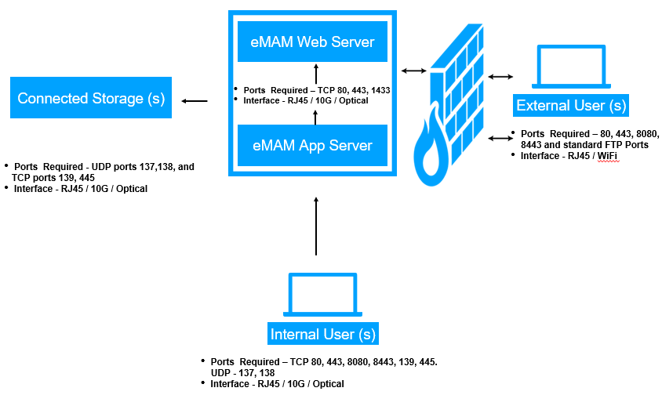

|  |  |
| --- | --- |
| Redundancy |  |

Customers can choose to install a Redundant eMAM Server to be used as Failover or DR in case of a failure of Primary eMAM Server.

To enable redundant eMAM Servers in Vault, Publish & Workgroup installations, each eMAM server replica is created with the same set of eMAM components, other applications, computing power, storage, and other operational parameters.

*\* Another level of redundancy can be achieved with redundant power supplies, CPU, RAM, RAID storage, etc. in the same server.*

*\* Data redundancy can be built into the storage system managed by eMAM. eMAM can also support multiple separate storage systems with different copies of the content.*

## 7.1 Redundant eMAM Server for Failover and Disaster Recovery (DR)

Redundant Systems can be configured in different ways, depending on customer’s requirement and workflow. Below are a couple of illustrations for DR & Failover Setups

Typically the DR setup may be located on a different site to ensure geographical diversity and recovery in case of Natural Calamities or Fire etc..

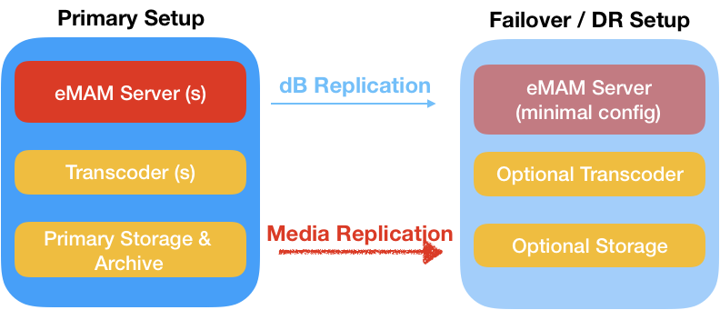

In some other cases, customers may choose to build failover on same site, with or without replicating Transcoders & Storage.

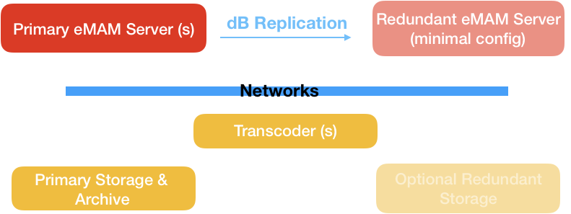

eMAM Database holds all necessary information to restore the entire system. Thus, in all cases it is suggested to schedule database replication to Redundant eMAM server. All Asset Information will be restored to the last replicated dB state in the event of failure.

All media will be automatically linked to the Redundant Server or made available from Redundant Storage (if available) in case of Failover.

## 7.2 Some basic requirement & guidelines for failover system -

1. In addition to Primary eMAM Server, the Redundant eMAM server(s) may be installed in the same premises to be used as Failover or in a different location to be used as a DR system. The redundant eMAM server however may be installed with minimal server specifications (mentioned in the document below).
2. Each Site may have its own set of transcoders and redundant storage to ensure trouble free switching and business process continuity. Customers may choose from a variety of redundant / DR storage options like – LTO, Object Storage, NAS, ODA etc..
3. Data can be replicated to selected Redundant Storage by setting up profiles and rules in eMAM Configuration. However, customers must ensure enough bandwidth and connectivity between two systems to ensure media replication.

2.     It is recommended to use domain names instead of IP for eMAM URL, Original, Proxy, Delivery, and archive configurations (Domain forwarding is much quicker than editing URLs in multiple configuration settings). If Domain Names are not setup, customer IT team will have to reconfigure URL’s or IP addresses for clients to point to Redundant eMAM Server.

3.     Customer should work with the archive middleware companies to make the DR plans for the archive.

4.     Server, Network, Storage and Archive may setup in both locations or in Cloud with accessibility from both locations.

## 7.3 eMAM Redundant Server License

For customers running eMAM Vault, Publish & Workgroup a back-up set of licenses is available at special price, please contact your Sales Representative for details. [emamsales@empressmam.com](mailto:emamsales@empressmam.com) , +1.888.808.3856

***Please note –***

*Mirroring of the database / servers and assets from primary location to DR location is outside of the eMAM configurations, dependent on third party tools. Archive Middleware can make duplicate copy of tapes and send those to a DR location. Replication can be configured in SQL server to mirror the database.*

*A major part of the DR configuration is from the networking side: pointing the domain names to appropriate servers/IP addresses. In some cases, the eMAM professional services team has to run a script to change the asset status to support the restore operations of the assets from archive to the newly provisioned storage.*

## 7.4 Options for 3rd Party Failover

1. **Microsoft Failover Clustering / Database Failover Clustering**
   1. Server Failover: <https://docs.microsoft.com/en-us/windows-server/failover-clustering/failover-clustering-overview>
   2. MSSQL Failover: <https://docs.microsoft.com/en-us/sql/sql-server/failover-clusters/install/create-a-new-sql-server-failover-cluster-setup?view=sql-server-2017>
2. **NEC Express Cluster**
   1. Software version: <https://www.nec.com/en/global/prod/expresscluster/index.html>
   2. Hardware version: <https://www.nec.com/en/global/prod/express/fault_tolerant/r320f/index.html>
3. **Cold – Manually cloning the Primary Server to the Failover server**
   1. Make a backup copy of the database and store in a separate location (Raid)
   2. Make frequent clones of the Server’s Drive. Place Clone into backup hardware and make changes to config and license files when backup server is needed in event of hardware issues on primary server.